

**FLM - FPT EDUCAITON LEARNING MATERIALS**

**Software Design Specification**

– Hanoi, August 2022 –

**Record of changeS**

| **Date** | **A* M, D** | **In charge** | **Change Description** |
| --- | --- | --- | --- |
| 28/05 | A | quannthe160206 | Thêm mô tả Overview (I) |
| 28/05 | A | quannthe160206 | Thêm code design User Profile (II.1-1.5) |
| 28/05 | A | quannthe160206 | Thêm code design Change Password (II.1-1.6) |
| 28/05 | A | trungnvhs160609 | Thêm code design User Login(II.1-1.3) |
| 28/05 | A | trungnvhs160609 | Thêm code design Reset Password(II.1-1.4) |
| 28/05 | A | tienlvhe161878 | Thêm code design View Setting List (II.2-2.3) |
| 28/05 | A | tienlvhe161878 | Thêm code design Edit Setting (II.2-2.4) |
| 28/05 | A | khoanthe161852 | Thêm code design View list account(II.2-2.1) |
| 28/05 | A | khoanthe161852 | Thêm code design View account detail (II.2-2.2) |
| 28/05 | A | quantnhe161199 | Thêm code design Home page(II.1-1.1) |
| 28/05 | A | quantnhe161199 | Thêm code design Register account(II.1-1.2) |
| 04/06 | A | trungnvhs160609 | Thêm code design Curriculum List(II.3-3.1) |
| 04/06 | A | trungnvhs160609 | Thêm code design New Curriculum(II.3-3.2) |
| 04/06 | A | trungnvhs160609 | Thêm code design View Curriculum(II.3-3.3) |
| 11/06 | A | quannthe160206 | Thêm code design Subject List(II.4-4.1) |
| 11/06 | A | quannthe160206 | Thêm code design New Subject(II.4-4.2) |
| 11/06 | A | quannthe160206 | Thêm code design Subject Import (II.4-4.3) |
| 11/06 | A | quannthe160206 | Thêm code design Subject Detail (II.4-4.4) |
| 11/06 | A | khoanthe161852 | Thêm code design Subject Predecessors(II.4-4.6) |
| 11/06 | A | khoanthe161852 | Thêm code design Subject Successors(II.4-4.7) |
| 11/06 | A | tienlvhe161878 | Thêm code design PLO List (II.5-5.1) |
| 11/06 | A | quantnhe161199 | Thêm code design Curriculum Edit (II.3-3.4) |
| 11/06 | A | quantnhe161199 | Thêm code design Curriculum Subject Detail (II.6-6.1) |
| 11/06 | A | quantnhe161199 | Thêm code design New Curriculum Subject (II.6-6.2) |
| 25/6 | A | khoanthe161852 | Thêm code design PO List (II.7-7.1) |
| 25/6 | A | khoanthe161852 | Thêm code design PO import (II.7-7.2) |
| 25/6 | A | khoanthe161852 | Thêm code design PO Detail(II.7-7.3) |
| 25/6 | A | khoanthe161852 | Thêm code design Subject Successors(II.4-4.6) |
| 25/6 | A | quannthe160206 | Thêm code design PLO import (II.5-5.3) |
| 25/6 | A | quannthe160206 | Thêm code design View Content Group List (II.8-8.3) |
| 25/6 | A | quannthe160206 | Thêm code design View Content Group Details (II.8-8.4) |
| 25/6 | A | trungnvhs160609 | Thêm mô tả chức năng List Decision |
| 25/6 | A | trungnvhs160609 | Thêm mô tả chức năng Add Decision |
| 25/6 | A | trungnvhs160609 | Thêm mô tả chức năng Detail Decision |
| 25/6 | A | trungnvhs160609 | Thêm mô tả chức năng Overview Decision |
| 25/6 | A | quantnhe161199 | Thêm mô tả chức năng View Combo List |
| 25/6 | A | quantnhe161199 | Thêm mô tả chức năng View Combo Detail |
| 25/6 | A | quantnhe161199 | Thêm mô tả chức năng View Elective List |
| 25/6 | A | quantnhe161199 | Thêm mô tả chức năng View Elective Details |
| 20/7 | A | quantnhe161199 | Thêm mô tả chức năng View Session List |
| 20/7 | A | quantnhe161199 | Thêm mô tả chức năng View Session Details |
| 20/7 | A | quantnhe161199 | Thêm mô tả chức năng Session Import |
| 20/7 | A | trungnvhs160609 | Thêm mô tả chức năng View Question List |
| 20/7 | A | trungnvhs160609 | Thêm mô tả chức năng View Question List |
| 20/7 | A | trungnvhs160609 | Thêm mô tả chức năng Question List |
| 20/7 | A | khoanthe161852 | Thêm mô tả chức năng View CLO List |
| 20/7 | A | khoanthe161852 | Thêm mô tả chức năng View CLO Detail |
| 20/7 | A | khoanthe161852 | Thêm mô tả chức năng CLO Import |
| 20/7 | A | khoanthe161852 | Thêm mô tả chức năng CLO-PLO Mapping |
| 20/7 | A | quannthe160206 | Thêm mô tả chức năng View Submit List |
| 20/7 | A | quannthe160206 | Thêm mô tả chức năng View Submit Details |
| 20/7 | A | quannthe160206 | Thêm mô tả chức năng Syllabus Import |
| 21/7 | A | tienlvhe161878 | Thêm mô tả chức năng Syllabus List |
| 21/7 | A | tienlvhe161878 | Thêm mô tả chức năng Syllabus Overview |
| 21/7 | A | tienlvhe161878 | Thêm mô tả chức năng Syllabus Edit |

*A - Added M - Modified D - Deleted

**Table of Contents**

I. Overview 8

1. Code Packages 8

2. Database Design 9

a. Database Schema 9

b. Table Description 9

II. Code Designs 10

1. User Access 10

1.1 View home page 10

1.2 Register new account 12

1.3 Login to the system 13

1.4 Reset password 14

1.5 Update user profile 15

1.6 Change password 17

2. System Admin 19

2.1 View list account 19

2.2 View account details 21

2.3 View setting list 22

2.4 Edit setting 23

3. Curriculum Management 24

3.1 View Curriculum List 24

3.2 Add New Curriculum 25

3.3 View Curriculum Overview 26

3.4 Edit Curriculum 27

4. Subject Management 28

4.1 View Subject List 28

4.2 Add New Subject 30

4.3 Import Subject 31

4.4 View Subject Detail 33

4.5 Mapping Subject-PLO 34

4.6 View Subject Predecessors 34

4.7 View Subject Successors 36

5. PLO Management 38

5.1 View PLO List 38

5.2 View PLO Details 40

5.3 Import PLO 40

5.4 Mapping PLO-PO 41

6. Curriculum Subject 43

6.1 View Curriculum Subject Details 43

6.2 Add New Curriculum Subject 45

7. PO Management 47

7.1 View PO List 47

7.2 Import PO 48

7.3 View PO Detail 50

8. Subject Groups 51

8.1 View Combo List 51

8.2 View Combo Detail 53

8.3 View Content Group List 54

8.4 View Content Group Details 55

8.5 View Elective List 56

8.6 View Elective Details 58

9. Syllabus Management 60

9.1 View Syllabus List 60

9.2 View Syllabus Overview 60

9.3 Add New Syllabus 60

9.4 Edit Syllabus 60

9.5 Import Syllabus 60

10. Decision Management 60

10.1 View Decision List 60

10.2 View Decision Details 62

10.3 Add New Decision 63

10.4 View Decision Overview 65

11. Syllabus Submit 66

11.1 View Submit List 66

11.2 View Submit Detail 66

12. Constructive Question 66

12.1 View Questions List 66

12.2 View Questions Details 66

12.3 Import Questions 66

13. Session Management 66

13.1 View Session List 66

13.2 View Session Details 66

13.3 Import Session 66

14. CLO Management 66

14.1 View CLO List 66

14.2 View CLO Details 67

14.3 Import CLO 67

14.4 Mapping CLO-PLO 67

15. Assessment Management 67

15.1 View Assessment List 67

15.2 View Assessment Details 67

16. Reference Material 67

16.1 View Material List 67

16.2 View Material Detail 67

# I. Overview

## 1. Code Packages

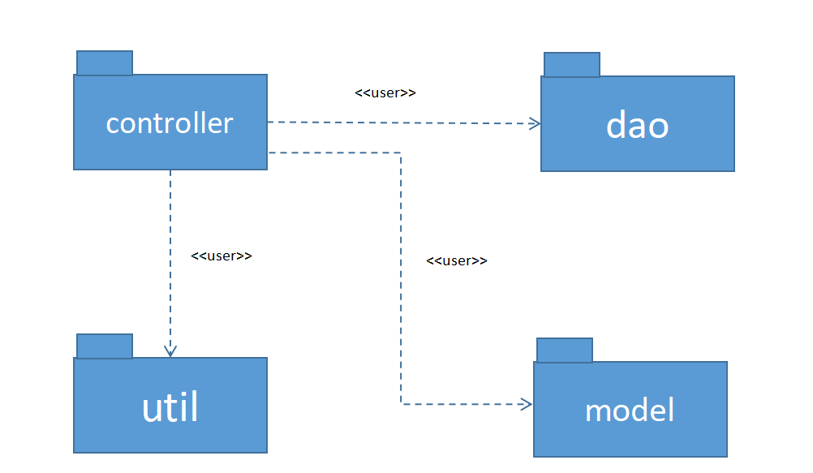

***Package descriptions***

| **No** | **Package** | **Description** |
| --- | --- | --- |
| *01* | *Controller* | *The controller package and its subpackage*  *controller.authentication house the classes responsible for*  *handling user interactions, processing requests, and*  *managing authentication-related functionality. These*  *classes act as the bridge between the UI and the underlying*  *application logic, ensuring smooth communication and*  *facilitating the execution of user-specific actions and*  *operations.* |
| *02* | *dao* | *The DAO package serves as a crucial component in the*  *data layer of the application. It abstracts the interaction*  *with the database, providing methods and interfaces for*  *accessing, manipulating, and persisting data entities. The*  *DAO classes ensure the separation of concerns and promote*  *code reusability by centralizing database-related operations*  *in a dedicated package.* |
| *03* | *model* | *The model package serves as a container for the*  *application's data models or entities, defining their*  *attributes, relationships, and behaviors. These classes*  *encapsulate the essential data structures and functionality*  *necessary to represent and manipulate core entities within the application. Separating the data models into a dedicated*  *package promotes organization, modularity, and*  *maintainability of the application's data layer.* |
| *04* | *util* | *The util package serves as a repository for reusable utility*  *classes and constants, simplifying development and*  *promoting consistency across the codebase. It enhances*  *code organization, encapsulation, and maintainability by*  *separating commonly used functionalities and values from*  *the rest of the application's logic.* |

## 2. Database Design

### a. Database Schema

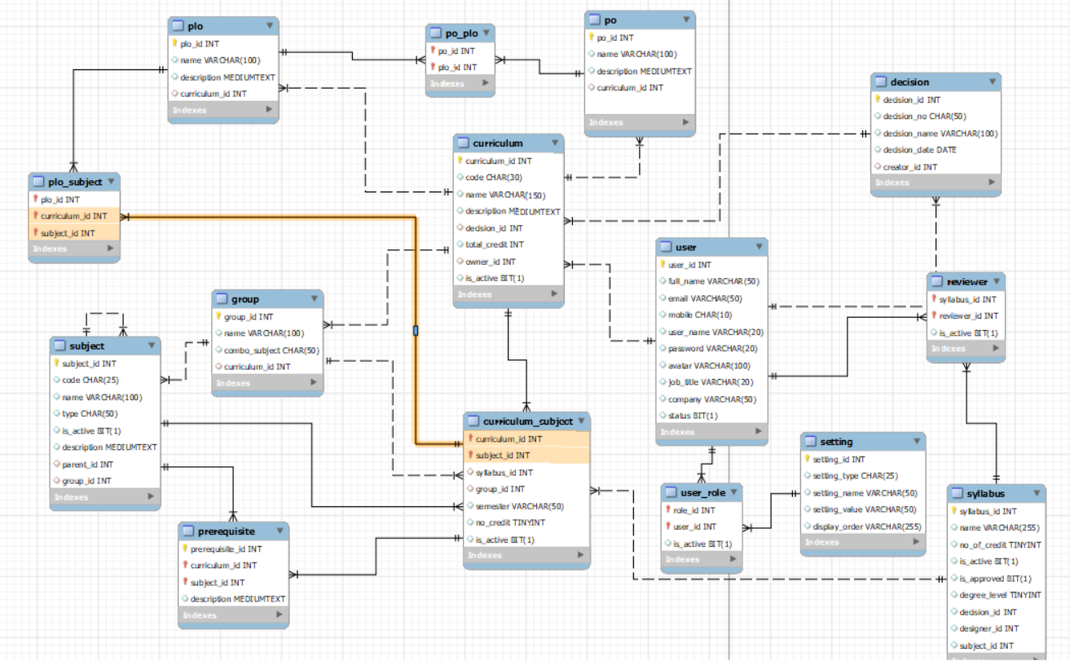

### b. Table Description

| **No** | **Table** | **Description** |
| --- | --- | --- |
| *01* | *User* | The user table contains all information about the account's full name, user name, mail, mobile, password, job, and company. |
| *02* | *Setting* | The ***settings*** table is to store master data:  • user roles  • system pages  • training types  • assessment types  • assessment categories |
| *03* | User_Role | Contains user id and role id to store each person's role. A person can have many roles but only 1 role can be active at a time |
| *04* | Subject |  |
| *05* | Curriculum |  |
| *06* | Curriculum_subject |  |
| *07* | Group |  |
| *08* | plo |  |
| *09* | plo_subject |  |
| *10* | prerequisite |  |
| *11* | po |  |
| *12* | po_plo |  |
| *13* | Decision |  |
| *14* | Reviewer |  |
| *15* | Syllabus |  |

# II. Code Designs

## User Access

### 1.1 View home page

#### a. Class Diagram

#### b. Sequence Diagram(s)

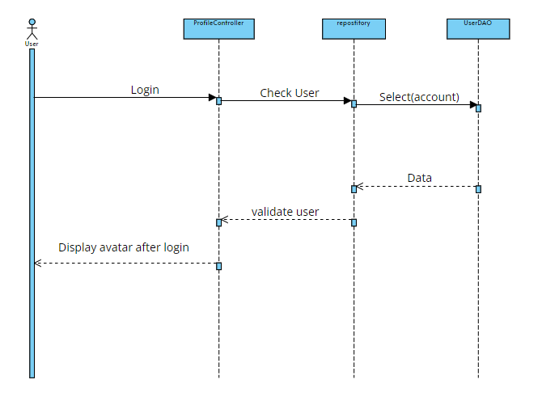

#### c. Database Queries

1.select * from user where email =?

2.select * from user where mobile =?

### 1.2 Register new account

#### a. Class Diagram

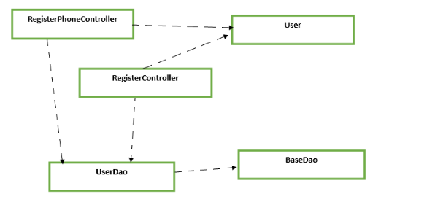

#### b. Sequence Diagram(s)

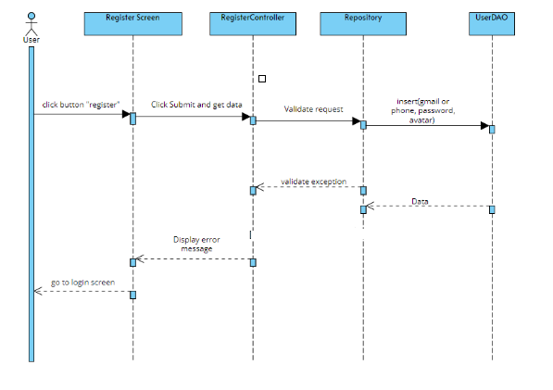

#### c. Database Queries

1:INSERT INTO `swp391_g3_flm`.`user` ( `mobile`, `password`, `avatar`) VALUES (?, ?,?)

2:INSERT INTO `swp391_g3_flm`.`user` ( `email`, `password`, `avatar`) VALUES (?, ?,?)

### 1.3 Login to the system

#### a. Class Diagram

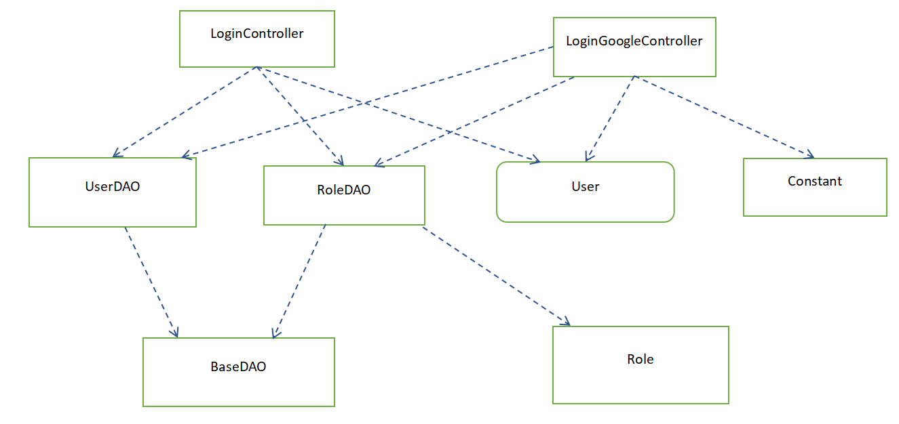

#### b. Sequence Diagram(s)

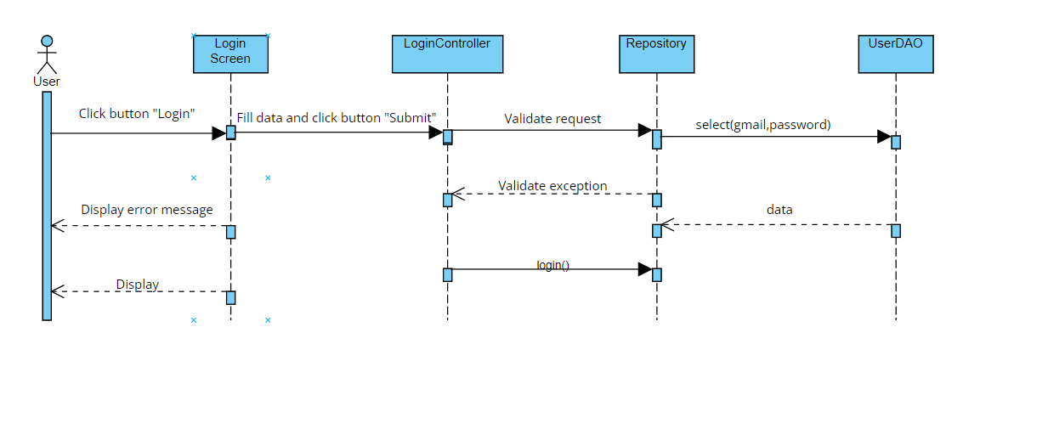

#### c. Database Queries

1.select * from user where email =? and password =?

2.select * from user where email=?

3.select * from user_role where user_id = ?

4.select * from setting where setting_id = ?

5.select * from user where full_name=?

6.select * from user where mobile=?

### 1.4 Reset password

#### a. Class Diagram

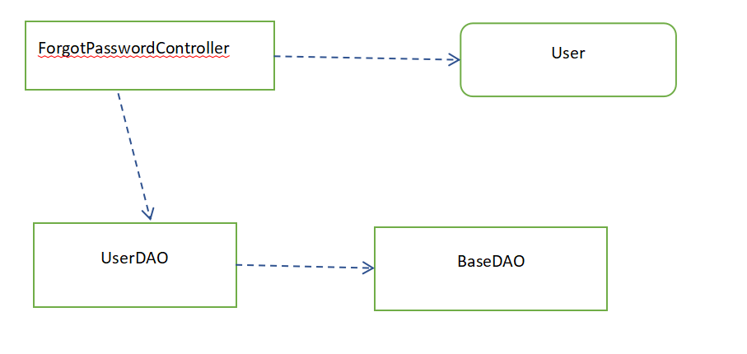

#### b. Sequence Diagram(s)

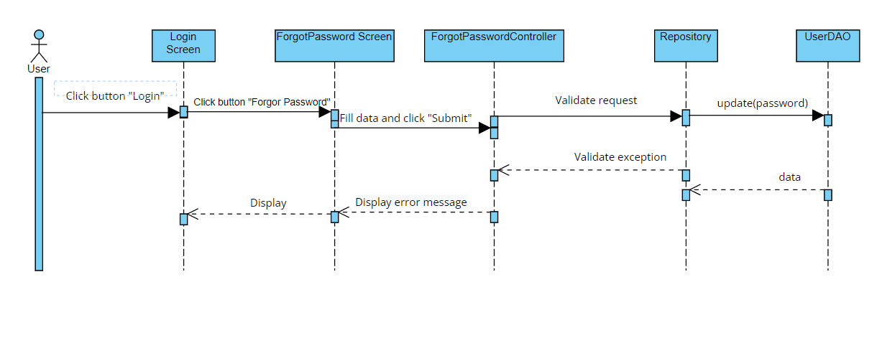

#### c. Database Queries

1.select * from user where email =?

2.select * from user where mobile =?

3.update user SET password =? WHERE user_id = ?

4.insert user_role(role_id,user_id) values ('1',?)

### 1.5 Update user profile

#### a. Class Diagram

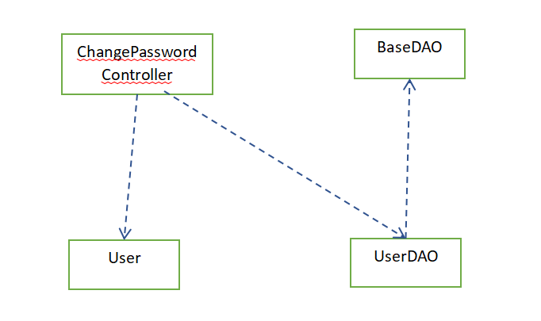

#### b. Sequence Diagram(s)

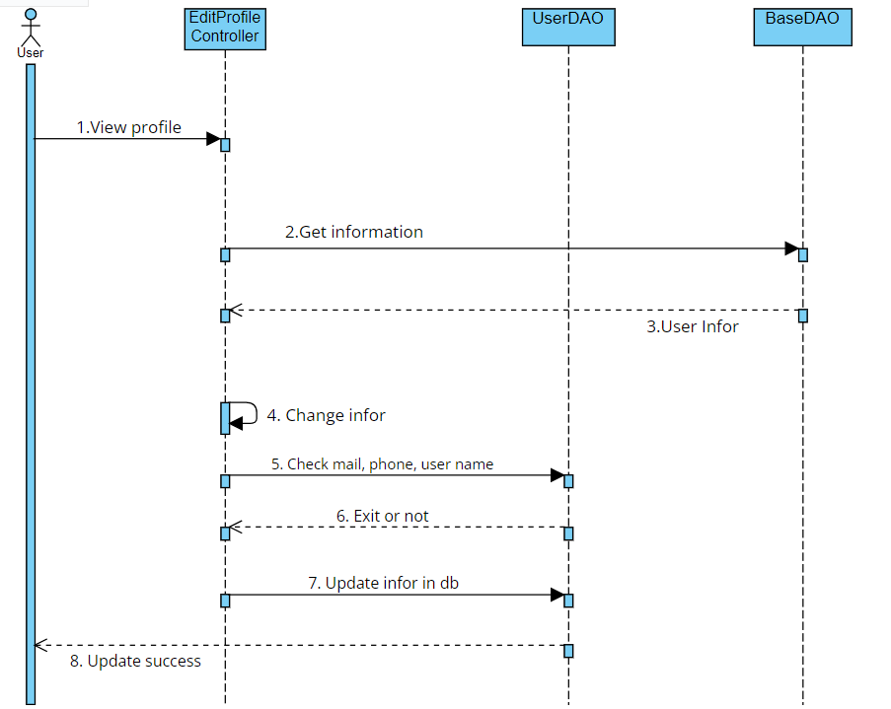

#### c. Database Queries

1. UPDATE user SET password = ? WHERE user_id=?;

### 1.6 Change password

#### a. Class Diagram

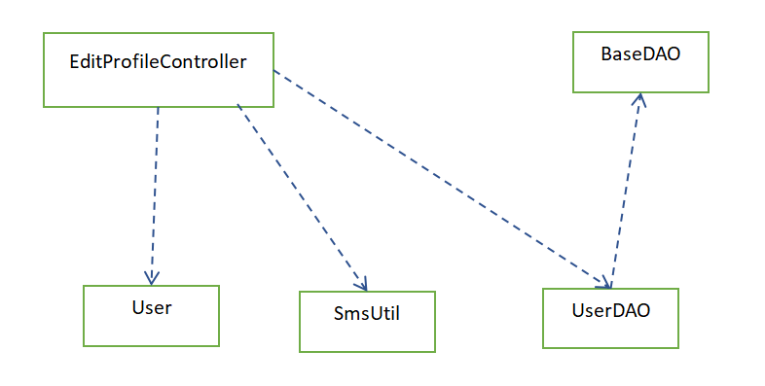

#### b. Sequence Diagram(s)

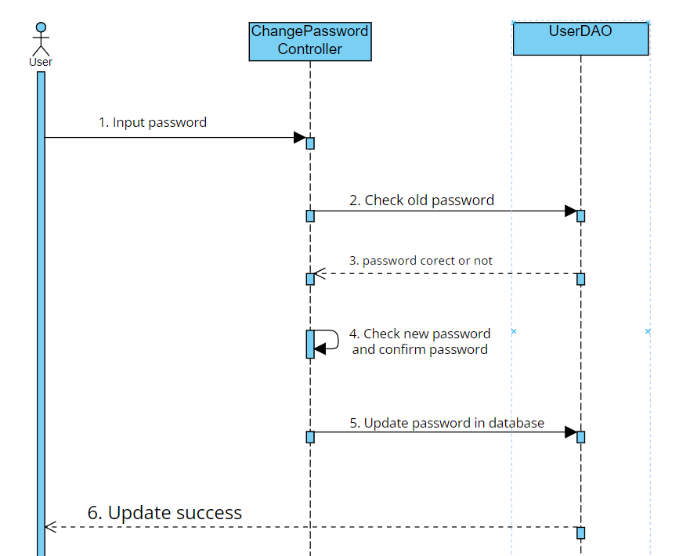

#### c. Database Queries

1. select * from user where mobile =?
2. select * from user where email =?
3. UPDATE user SET full_name = ?, email = ?, mobile = ?, user_name = ? job_title = ?, company = ? WHERE (user_id = ?);
4. UPDATE user SET avatar = ? WHERE (user_id = ?);

## System Admin

### 2.1 View list account

#### a. Class Diagram

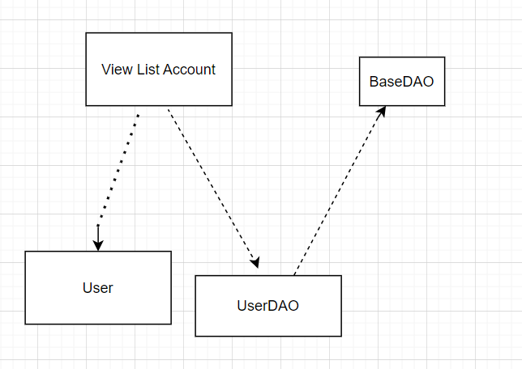

#### b. Sequence Diagram(s)

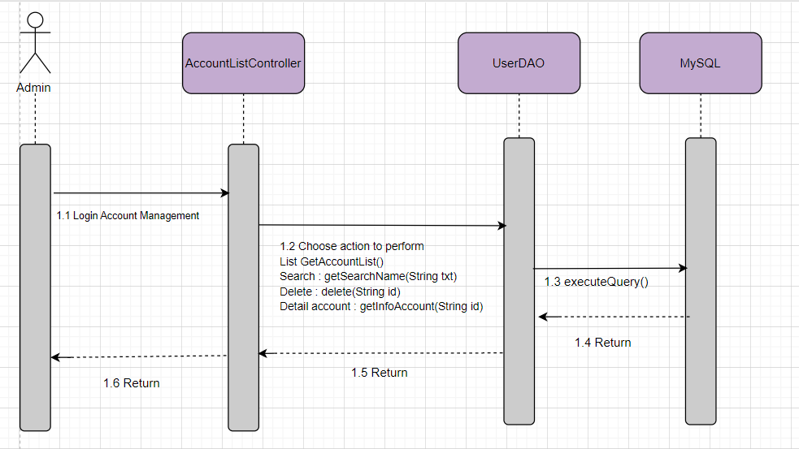

#### c. Database Queries

1. select * from user
2. "select * from user"

+ " where full_name like '" + "%" + txt + "%" + "'"

+ " OR email like '" + "%" + txt + "%" + "'"

+ " OR mobile like '" + "%" + txt + "%" + "'"

+ " OR job_title like '" + "%" + txt + "%" + "'";

1. delete from user where user_id=?
2. select * from user in order by user_id asc
3. select * from user in order by user_id desc
4. select * from user in order by full_name asc
5. select * from user in order by full_name desc
6. select * from user in order by email asc
7. select * from user in order by email desc
8. select * from user in order by mobile asc
9. select * from user in order by mobile desc
10. select * from user in where status = 0
11. select * from user in where status = 1

### 2.2 View account details

#### a. Class Diagram

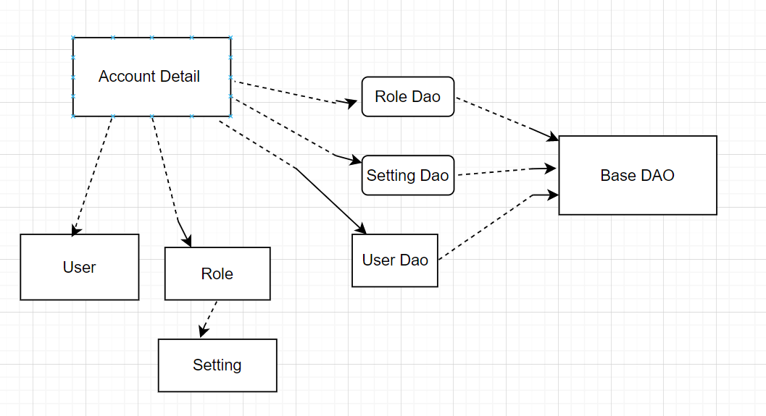

#### b. Sequence Diagram(s)

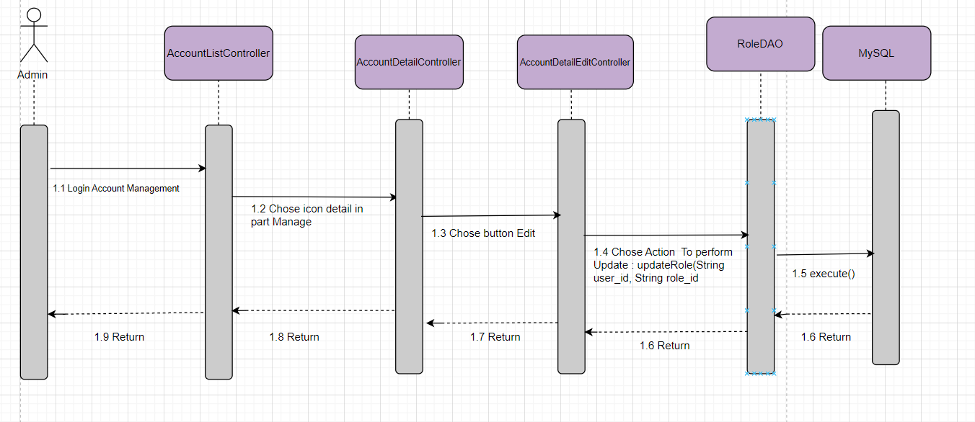

#### c. Database Queries

1. select * from setting
2. UPDATE user_role "

+ "SET role_id = ? "

+ "WHERE (user_id = ?);"

1. select user.user_id , full_name, email, mobile, user_name, avatar, job_title, company,setting_name\n"

+ "from user join user_role\n"

+ "on user_role.user_id = user.user_id \n"

+ "join setting on user_role.role_id = setting.setting_id "

+ " where user.user_id ='" + id + "' ";

### 2.3 View setting list

#### a. Class Diagram

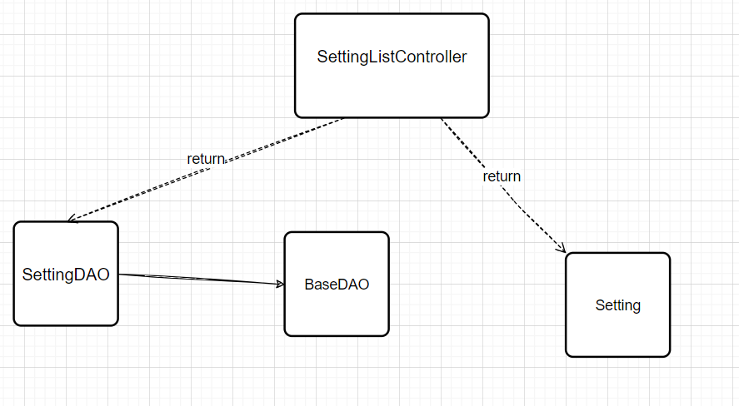

#### b. Sequence Diagram(s)

#### c. Database Queries

1 SELECT * FROM setting;

2 SELECT * FROM setting where setting_name like ?;

3 SELECT DISTINCT setting_type FROM setting;

4 SELECT * FROM setting where setting_type like ?;

### 2.4 Edit setting

#### a. Class Diagram

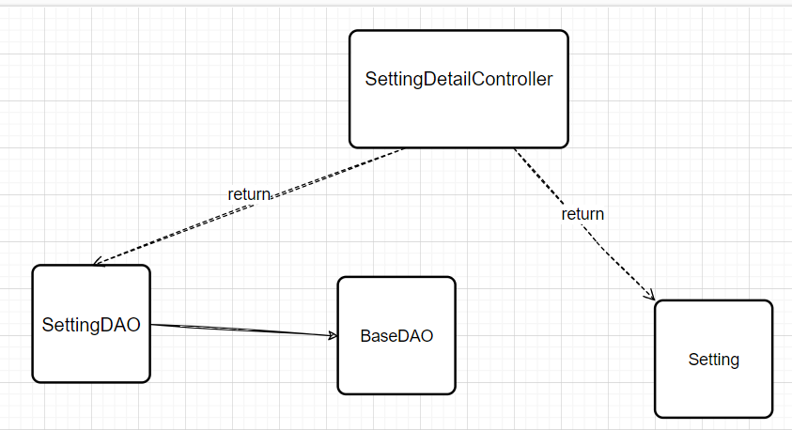

#### b. Sequence Diagram(s)

#### c. Database Queries

1 SELECT * FROM setting where setting_id like ?;

2 UPDATE swp391_g3_flm.setting "

SET setting_name = ?,

setting_value = ?,

display_order = ?

+ WHERE setting_id = ?;

## Curriculum Management

### 3.1 View Curriculum List

#### a.Class Diagram

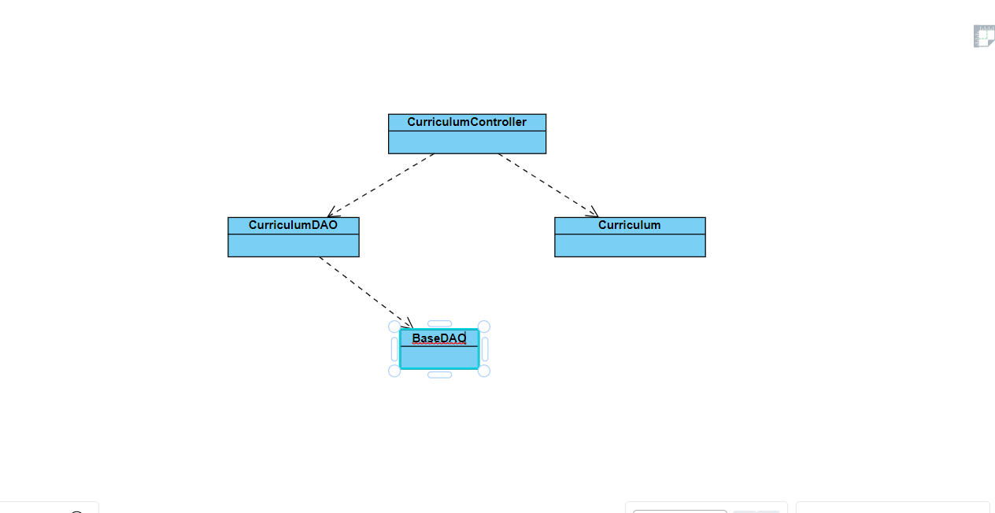

#### b. Sequence Diagram(s)

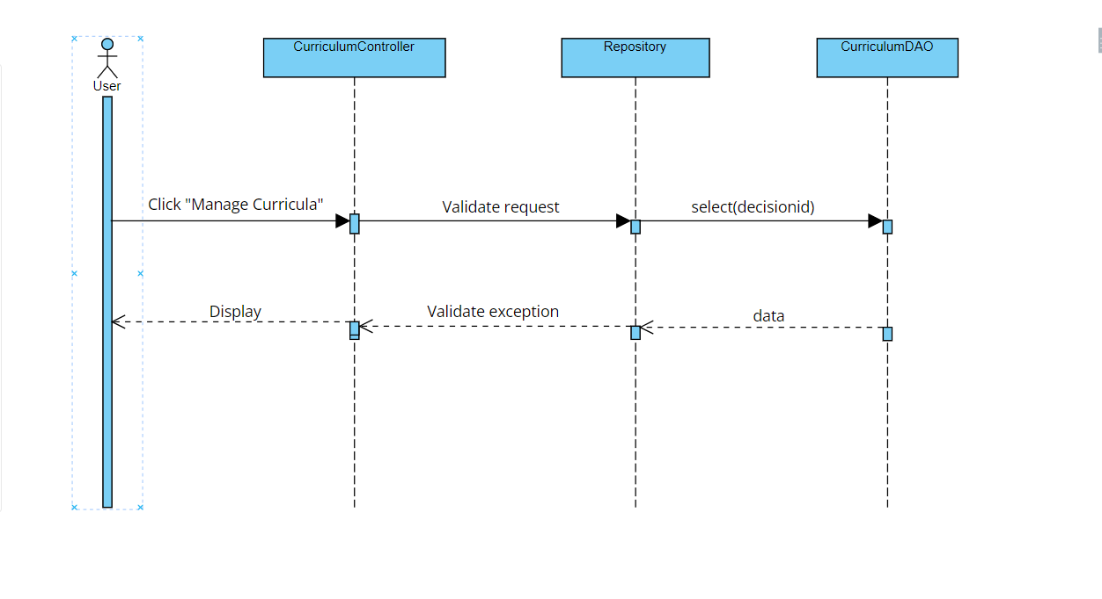

#### c. Database Queries

SELECT * FROM curriculum where code like ?;

### 3.2 Add New Curriculum

#### a.Class Diagram

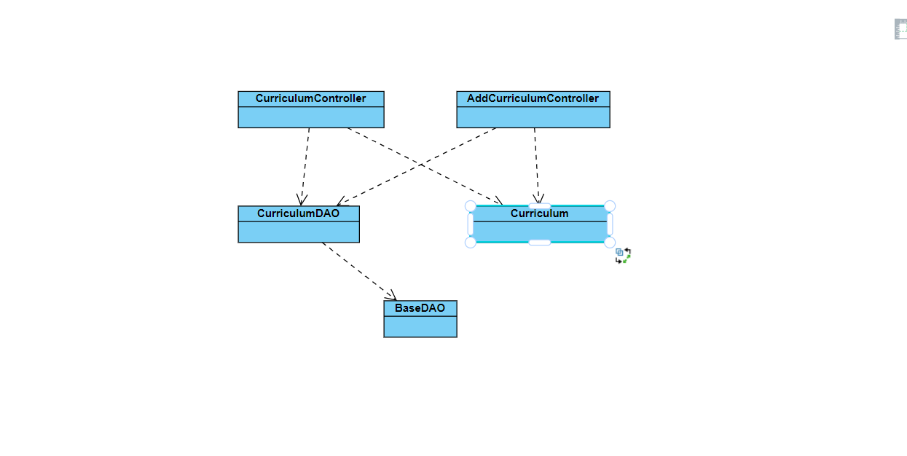

#### b. Sequence Diagram(s)

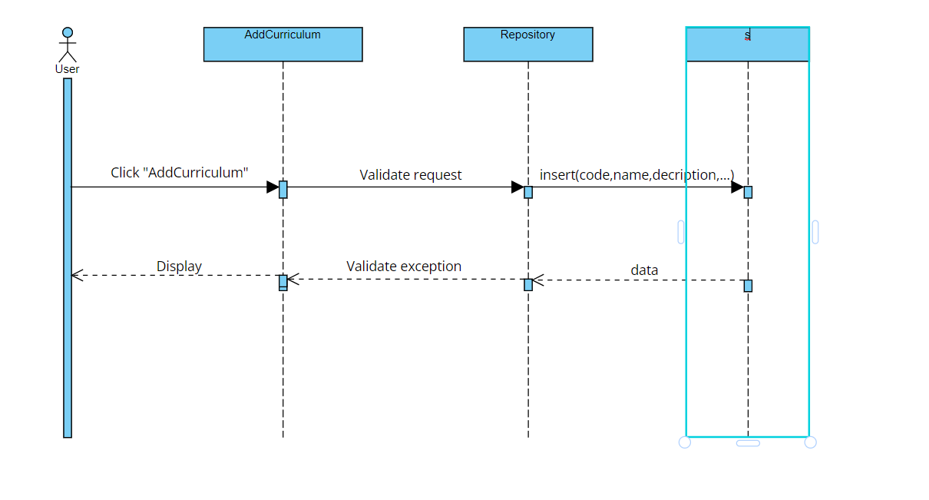

#### c. Database Queries

select * from curriculum where code =?

INSERT INTO `swp391_g3_flm`.`curriculum` (`code`, `name`, `description`, `decision_id`, `total_credit`, `owner_id`)"

+ " VALUES (?, ?, ?, ?, ?, ?);

select * from curriculum

### 3.3 View Curriculum Overview

#### a.Class Diagram



#### b. Sequence Diagram(s)

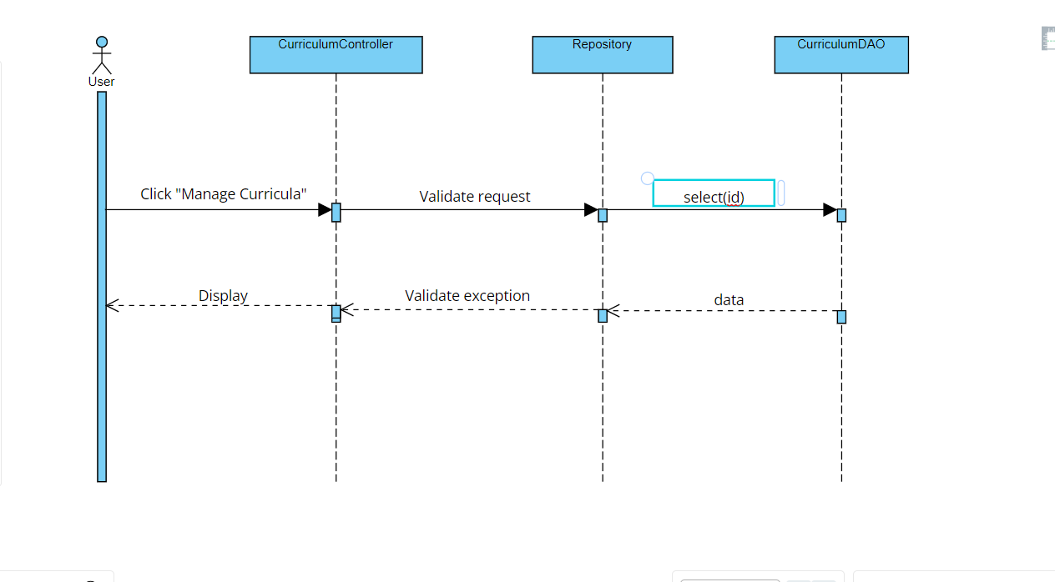

#### c. Database Queries

SELECT * FROM curriculum where curriculum_id = ?;

select * from decision where decision_id = ?

return decision_id;

### 3.4 Edit Curriculum

#### a.Class Diagram

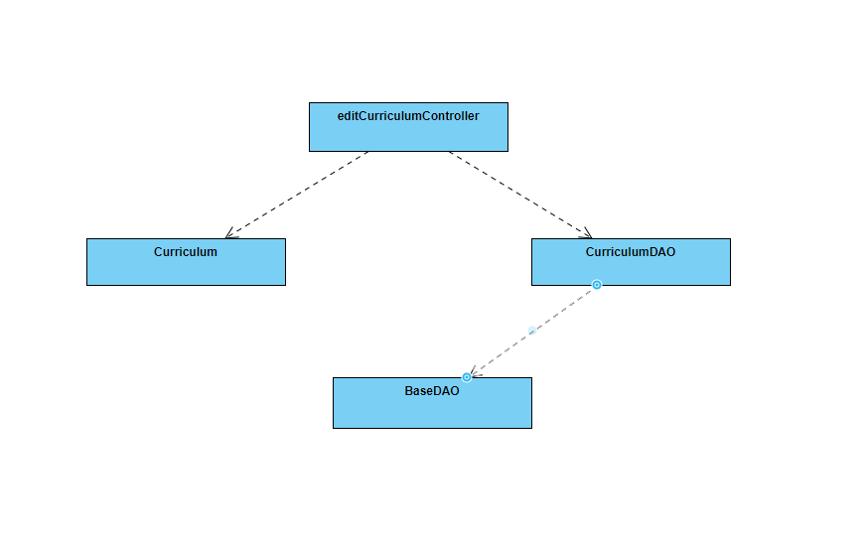

#### b. Sequence Diagram(s)

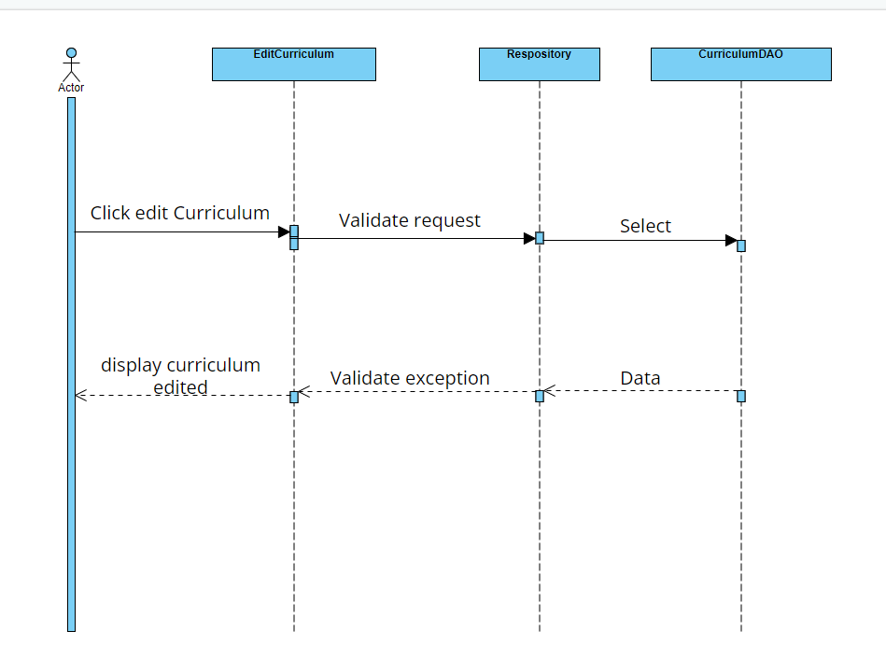

#### c. Database Queries

UPDATE `swp391_g3_flm`.`curriculum`"

+”SET code = ? ,name = ? , description = ? , decision_id = ? , total_credit = ? , owner_id = ?"

+ "Where curriculum_id = ?"

## Subject Management

### 4.1 View Subject List

#### a.Class Diagram

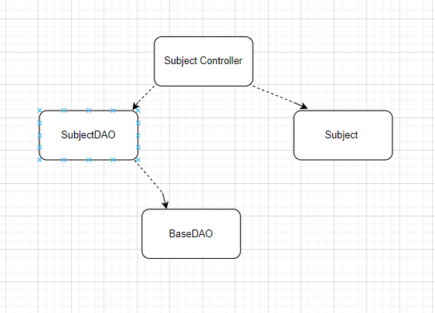

#### b. Sequence Diagram(s)

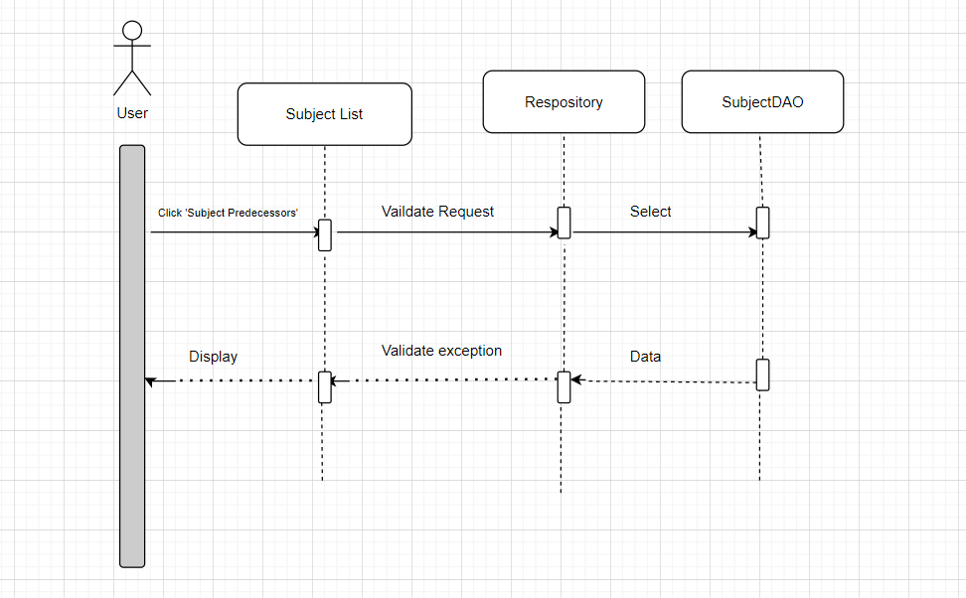

#### c. Database Queries

String strSelect = "SELECT * FROM swp391_g3_flm.subject\n" +

"order by subject_id\n" +

"limit ?, 10;";

String strSelect = "select * from subject where code = ?;";

String strSelect = "select * from subject where code like ?;";

String strSelect = "select * from subject where name like ?;";

"select count(*) from subject";

### 4.2 Add New Subject

#### a.Class Diagram

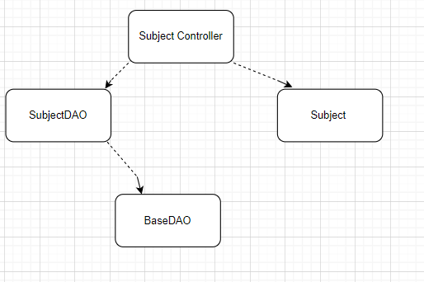

#### b. Sequence Diagram(s)

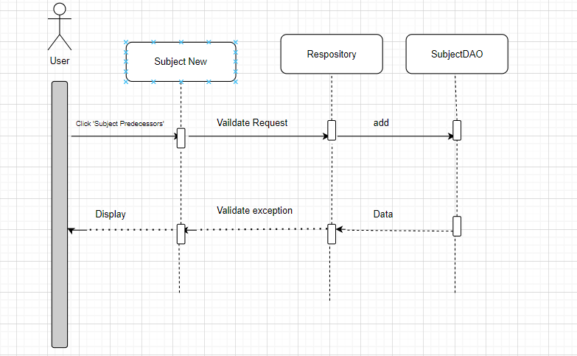

#### c. Database Queries

String strAdd = "INSERT INTO `swp391_g3_flm`.`subject` (`code`, `name`,`type`, `is_active`, `description`, `parent_id`)"

+ " VALUES (?, ?, ?, b?, ?, ?);";

### 4.3 Import Subject

#### a.Class Diagram



#### b. Sequence Diagram(s)

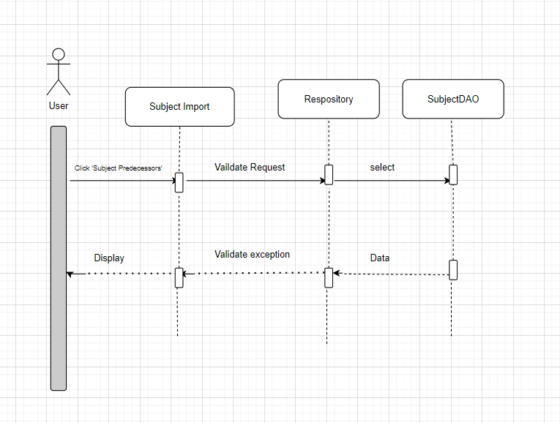

#### c. Database Queries

### 4.4 View Subject Detail

#### a.Class Diagram



#### b. Sequence Diagram(s)

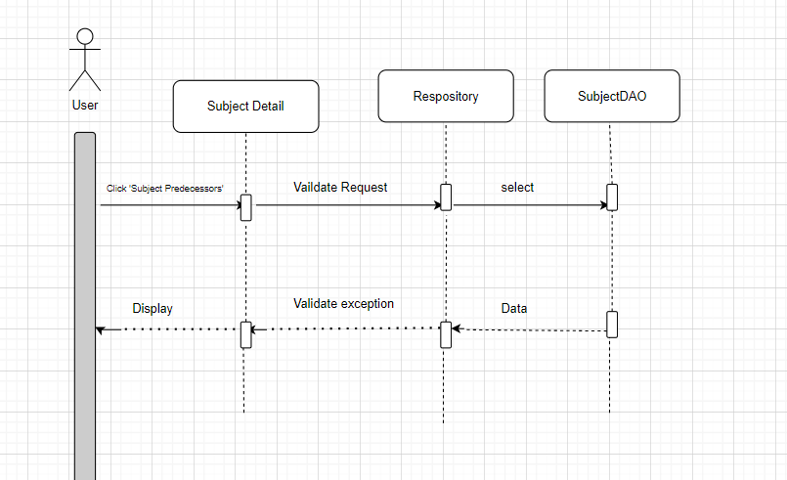

#### c. Database Queries

String strSelect = "select * from subject where code = ?;";

### 4.5 Mapping Subject-PLO

#### a.Class Diagram

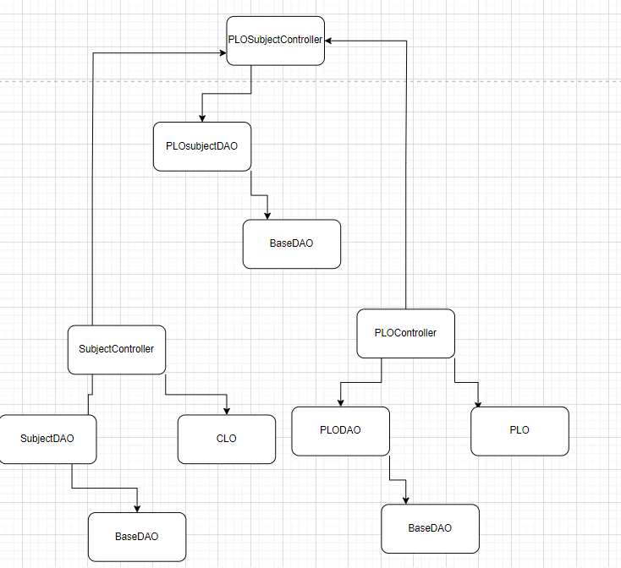

#### b. Sequence Diagram(s)

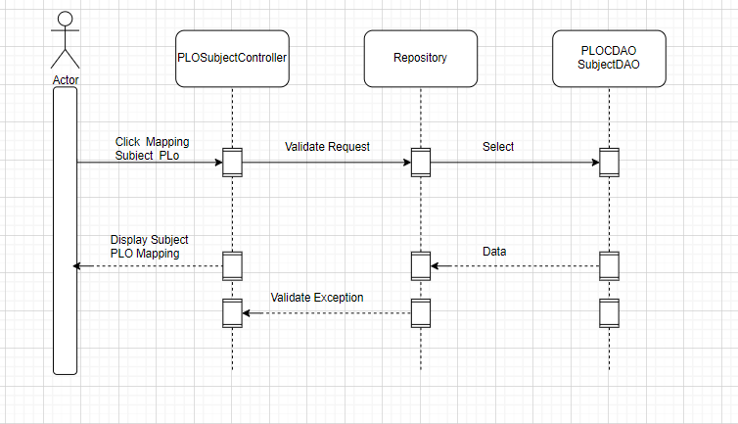

#### c. Database Queries

### 4.6 View Subject Predecessors

#### a.Class Diagram

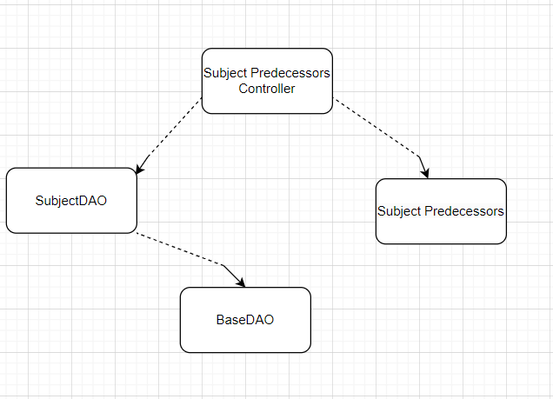

#### b. Sequence Diagram(s)

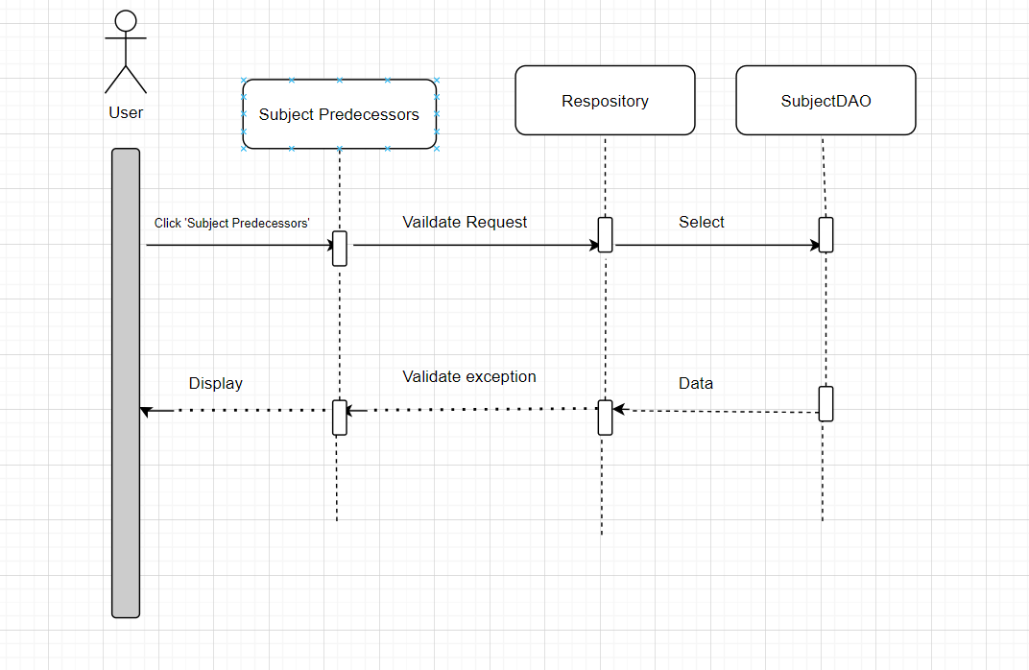

#### c. Database Queries

select d.subject_id, d.code, d.name, d.type, d.is_active, d.description, d.parent_id, d.group_id

from subject s join subject d

on s.subject_id = d.parent_id

order by d.subject_id

Limit ?,10

select DISTINCT d.subject_id, d.code, d.name, d.type, d.is_active, d.description, d.parent_id, d.group_id

from subject s join subject d

on s.subject_id = d.parent_id

WHERE d.name like ?

select DISTINCT d.subject_id, d.code, d.name, d.type, d.is_active, d.description, d.parent_id, d.group_id

from subject s join subject d

on s.subject_id = d.parent_id

WHERE d.code like ?

### 4.7 View Subject Successors

#### a.Class Diagram

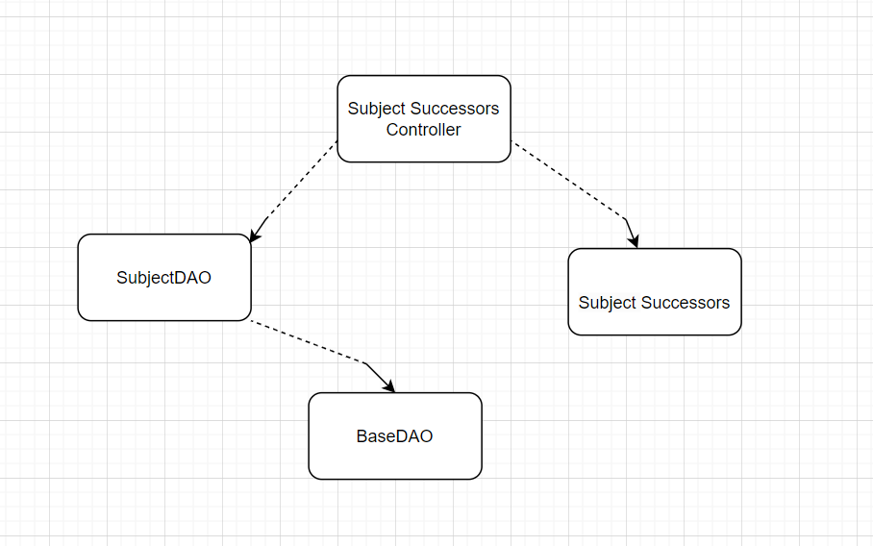

#### b. Sequence Diagram(s)

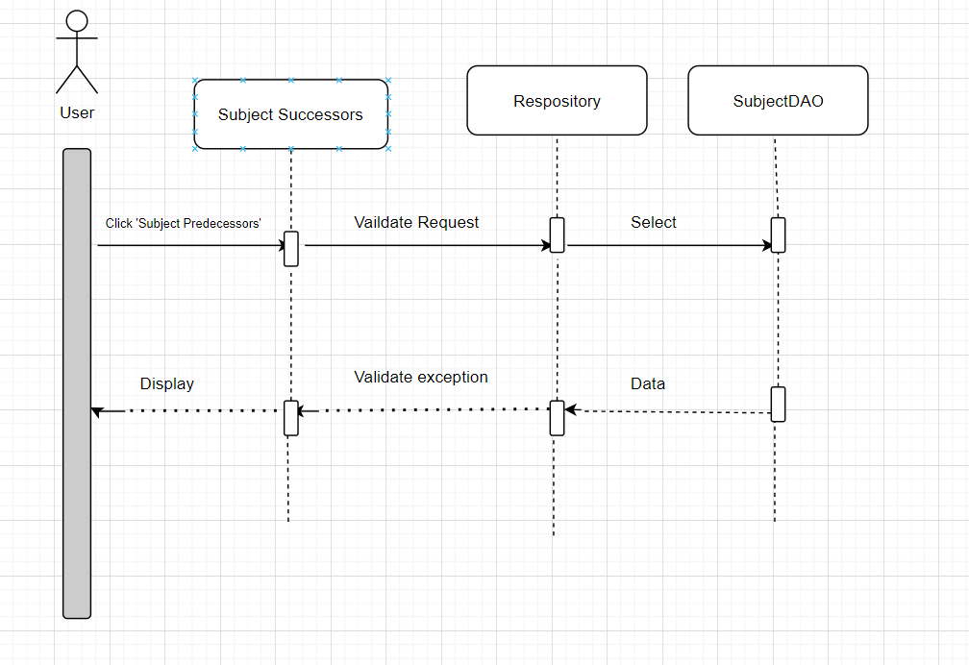

#### c. Database Queries

select DISTINCT s.subject_id, s.code, s.name, s.type, s.is_active, s.description, s.parent_id, s.group_id

from subject s join subject d

on s.subject_id = d.parent_id

WHERE s.parent_id is null

order by s.subject_id

Limit ?,10;

select DISTINCT s.subject_id, s.code, s.name, s.type, s.is_active, s.description, s.parent_id, s.group_id

from subject s join subject d

on s.subject_id = d.parent_id

WHERE s.parent_id is null and s.name like ?

select DISTINCT s.subject_id, s.code, s.name, s.type, s.is_active, s.description, s.parent_id, s.group_id

from subject s join subject d

on s.subject_id = d.parent_id

WHERE s.parent_id is null and s.code like ?

## PLO Management

### 5.1 View PLO List

#### a.Class Diagram

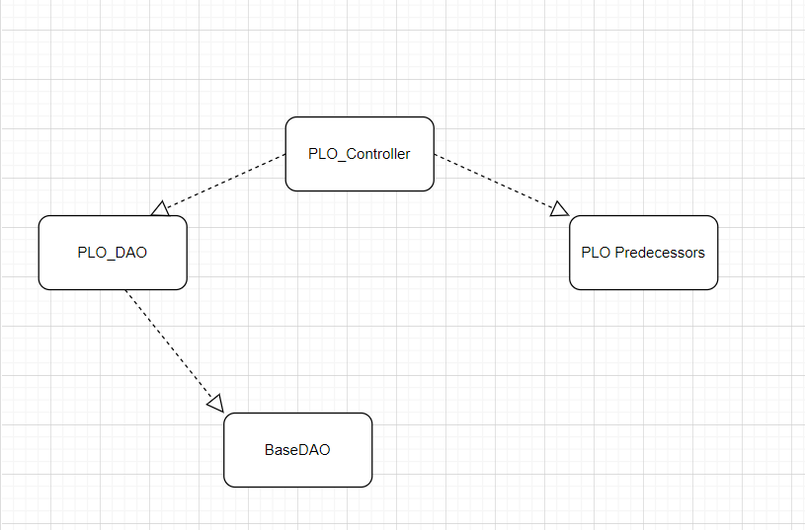

#### b. Sequence Diagram(s)

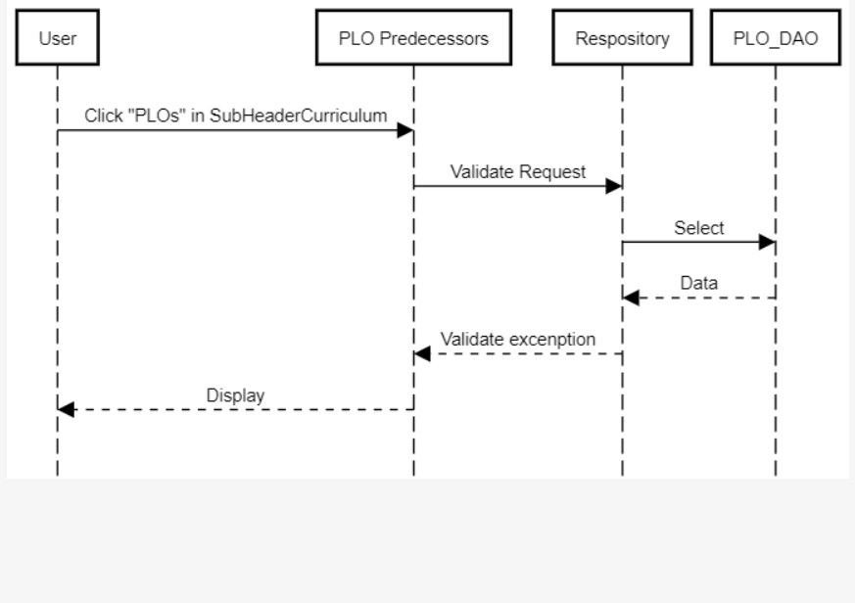

#### c. Database Queries

select count(*) from plo where curriculum_id = ?;

SELECT * FROM swp391_g3_flm.plo where curriculum_id = ?

order by plo_id

limit ?, 10;

### 5.2 View PLO Details

#### a.Class Diagram

#### b. Sequence Diagram(s)

#### c. Database Queries

### 5.3 Import PLO

#### a.Class Diagram

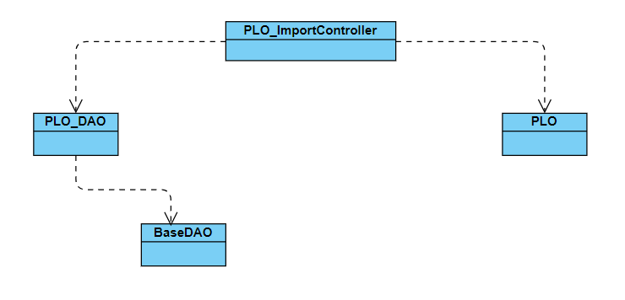

#### b. Sequence Diagram(s)

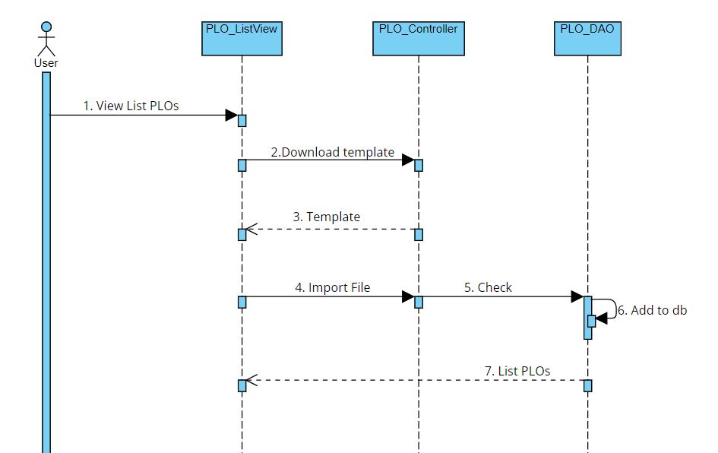

#### c. Database Queries

1. select count(*) from plo where curriculum_id = ?;
2. SELECT * FROM swp391_g3_flm.plo where curriculum_id = ? order by plo_id limit ?, 10;
3. INSERT INTO `swp391_g3_flm`.`plo` (`name`, `description`, `curriculum_id`) VALUES (?, ?, ?);

### 5.4 Mapping PLO-PO

#### a.Class Diagram

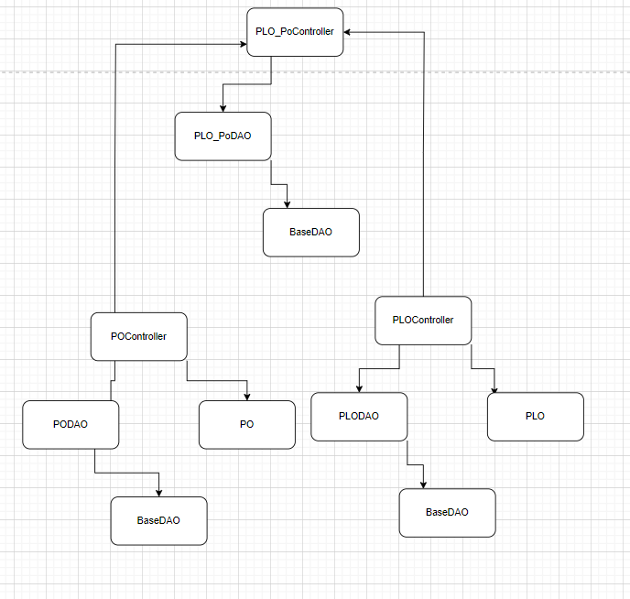

#### b. Sequence Diagram(s)

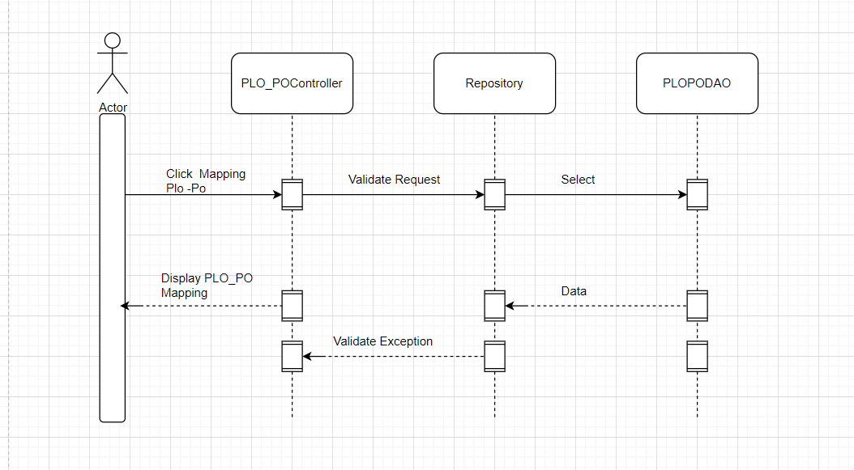

#### c. Database Queries

"select * FROM po_plo pp\n"

+ "where pp.po_id = ? and pp.plo_id = ?;"

""

+ "DELETE FROM `po_plo`\n"

+ "WHERE po_id = ? AND plo_id = ?";

+ "INSERT INTO `po_plo` (`po_id`, `plo_id`) VALUES (?, ?);";

## Curriculum Subject

### 6.1 View Curriculum Subject Details

#### a.Class Diagram

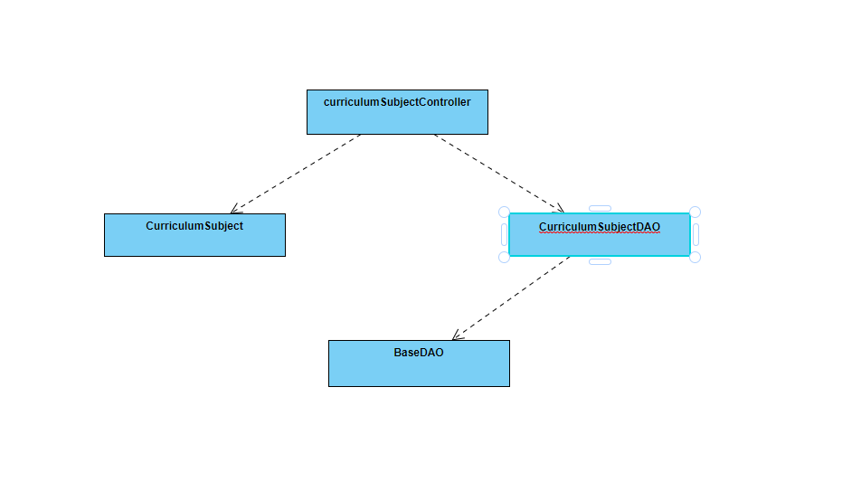

#### b. Sequence Diagram(s)

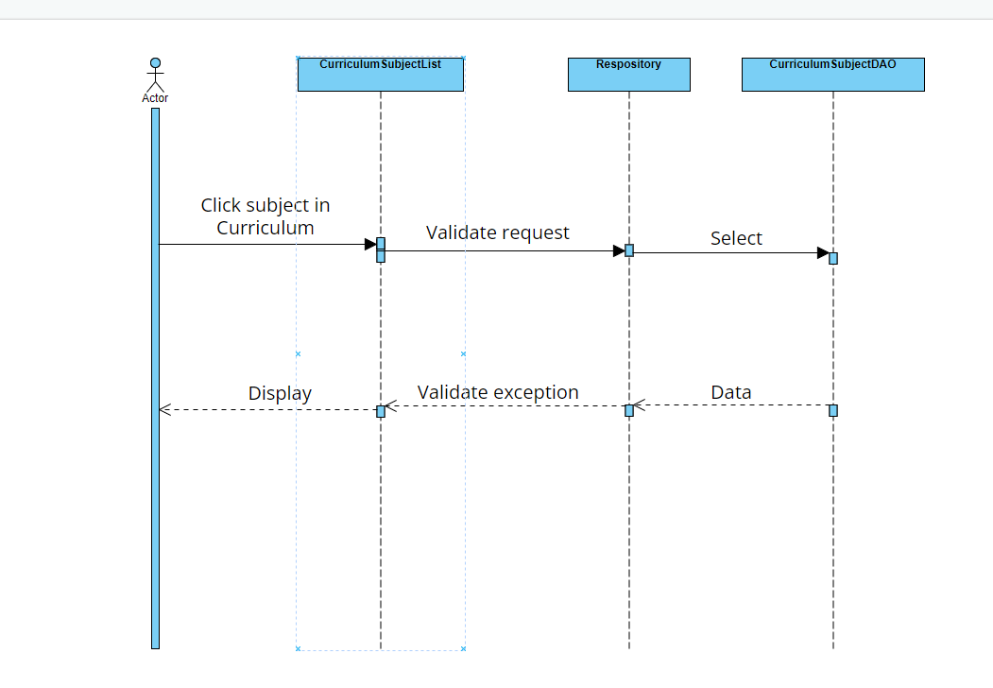

#### c. Database Queries

"select curriculum_subject.subject_id,code,name,semester,no_credit "

+ "from curriculum_subject join subject on curriculum_subject.subject_id = subject.subject_id "

+ "where curriculum_id = ? and type <> 'subcombo'"

+ "order by curriculum_subject.subject_id\n"

+ "limit ?,3; "

"select count(*) "

+ "from curriculum_subject join subject on curriculum_subject.subject_id = subject.subject_id "

+ "where curriculum_id = ? and type <> 'subcombo'"

### 6.2 Add New Curriculum Subject

#### a.Class Diagram

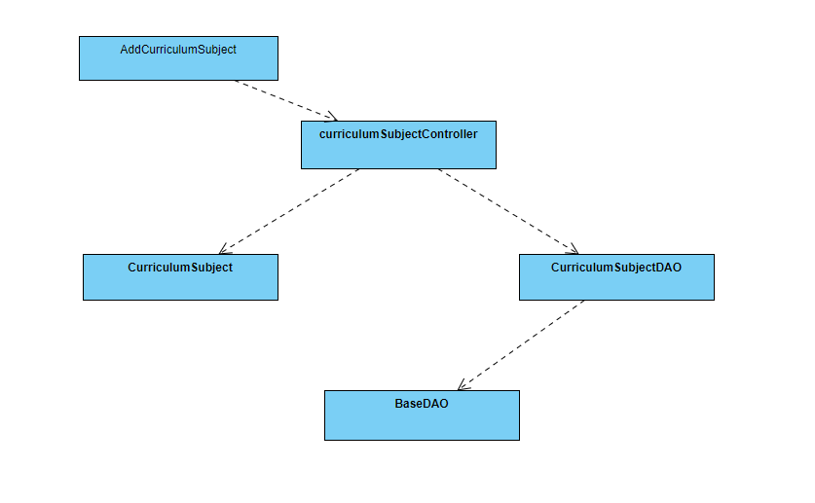

#### b. Sequence Diagram(s)

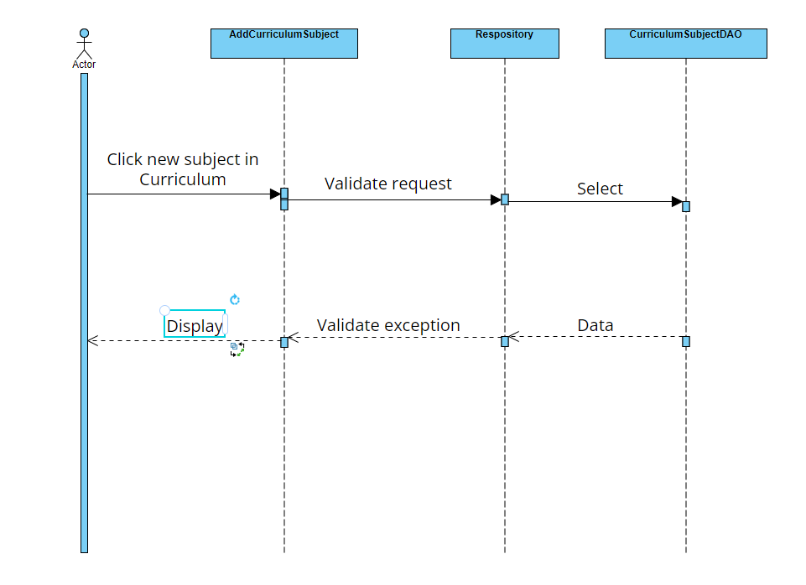

#### c. Database Queries

"select * from curriculum_subject where subject_id =? and curriculum_id= ?"

"select * from `group` where group_id =? "

"select * from subject where subject_id =? "

"select * from syllabus where syllabus_id =? "

"INSERT INTO `swp391_g3_flm`.`curriculum_subject` (`curriculum_id`, `subject_id`,`syllabus_id`, `group_id`, `semester`, `no_credit`, `is_active`)"

+ " VALUES (?, ?, ?, b?, ?, ?,?);"

## PO Management

### 7.1 View PO List

#### a.Class Diagram

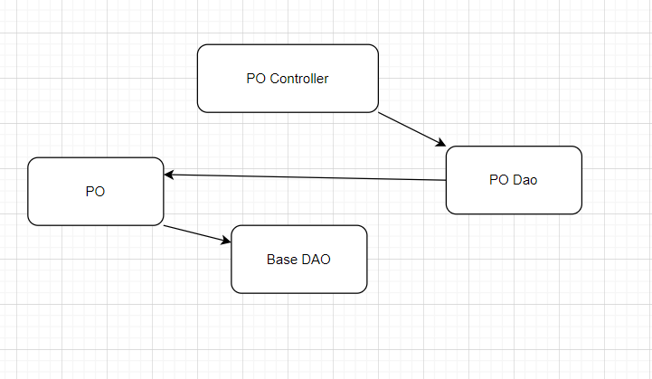

#### b. Sequence Diagram(s)

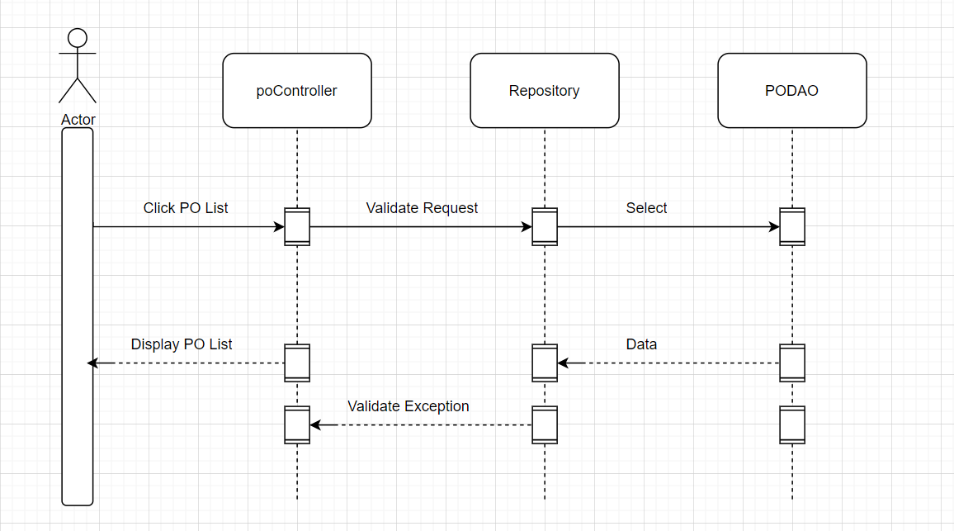

#### c. Database Queries

SELECT po_id, p.name, p.description, p.curriculum_id, p.is_active, c.code

FROM po p left join curriculum c on p.curriculum_id = c.curriculum_id

order by po_id

limit 0, 10;

select count(*) from po

"SELECT po_id, p.name, p.description, p.curriculum_id, p.is_active, c.code\n"

+ "FROM po p left join curriculum c on p.curriculum_id = c.curriculum_id "

+ " where p.name like '" + "%" + txt + "%" + "'"

+ " OR po_id like '" + "%" + txt + "%" + "'"

+ " OR c.code like '" + "%" + txt + "%" + "'";

### 7.2 Import PO

#### a.Class Diagram

b. Sequence Diagram(s)

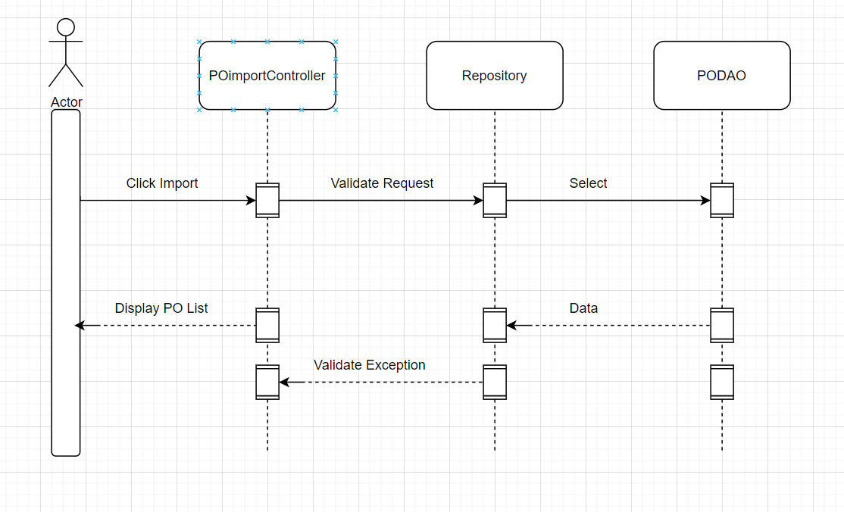

#### c. Database Queries

"INSERT INTO `swp391_g3_flm`.`po` (`name`, `description`, `is_active`)"

+ " VALUES (?, ?, b?);";

### 7.3 View PO Detail

#### a.Class Diagram



#### b. Sequence Diagram(s)

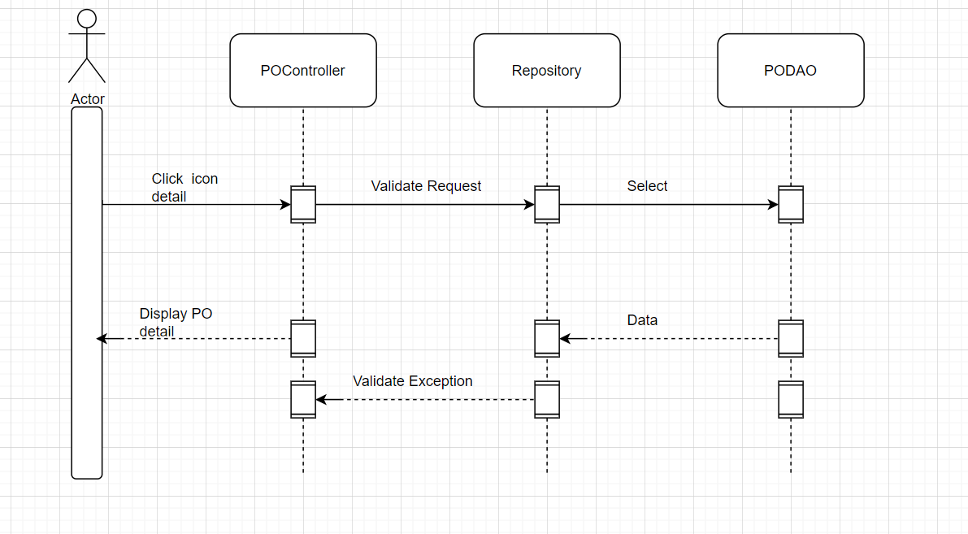

#### c. Database Queries

"SELECT po_id, p.name, p.description, p.curriculum_id, p.is_active, c.code\n"

+ "FROM po p left join curriculum c on p.curriculum_id = c.curriculum_id \n"

+ "where po_id = ?;";

## Subject Groups

### 8.1 View Combo List

#### a.Class Diagram

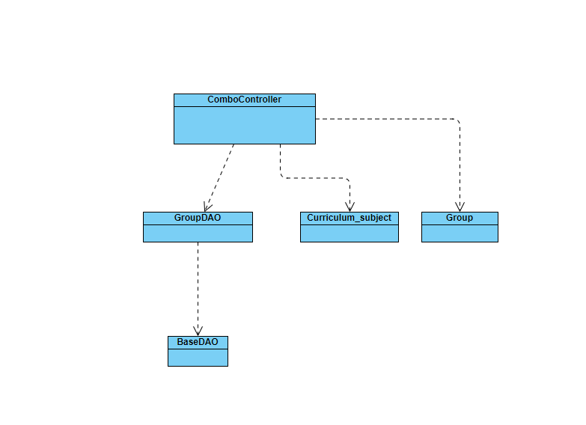

#### b. Sequence Diagram(s)

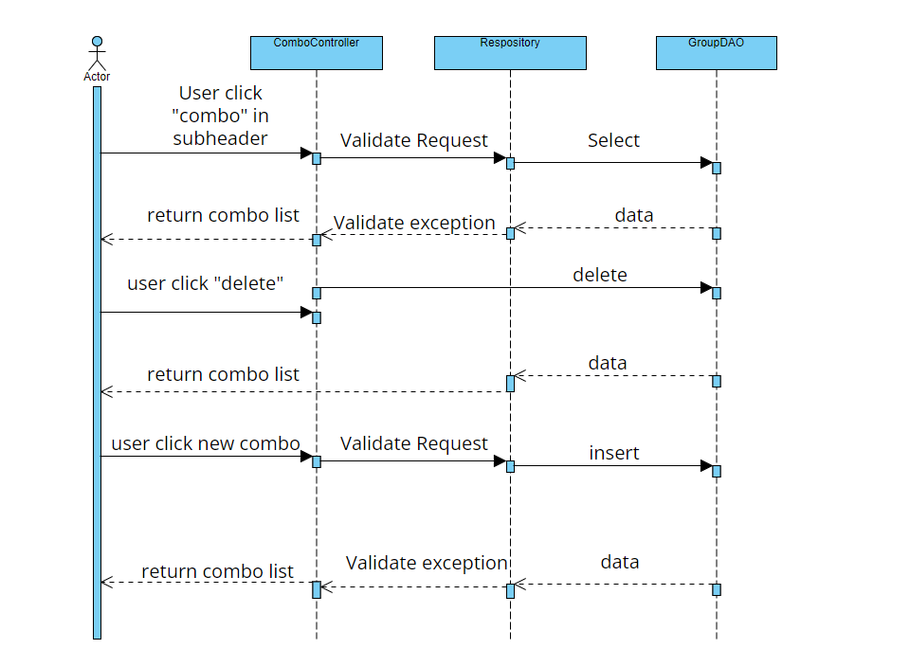

#### c. Database Queries

SELECT `group`.group_id,`group`.name,subject.code,subject.name "

+ "FROM swp391_g3_flm.curriculum_subject join subject "

+ "on curriculum_subject.subject_id = subject.subject_id "

+ "join `group` on `group`.group_id = subject.group_id "

+ "where curriculum_subject.curriculum_id = ? and type = 'Combo'

### 8.2 View Combo Detail

#### a.Class Diagram

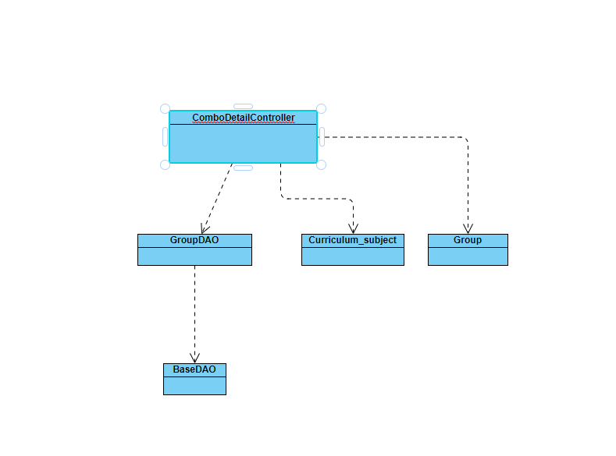

#### b. Sequence Diagram(s)

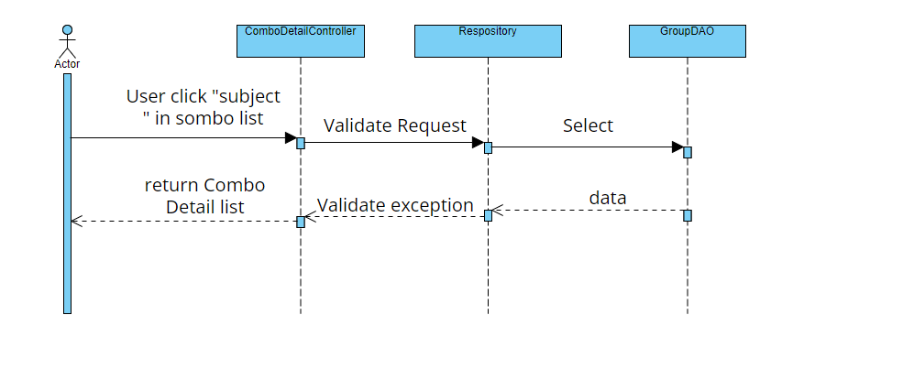

#### c. Database Queries

SELECT subject.subject_id,subject.name,subject.code,curriculum_subject.semester "

+ "FROM swp391_g3_flm.curriculum_subject join subject "

+ "on curriculum_subject.subject_id = subject.subject_id "

+ "join `group` on `group`.group_id = subject.group_id "

+ "where curriculum_subject.curriculum_id = ? and type = 'Default' and `group`.group_id = ?

### 8.3 View Content Group List

#### a.Class Diagram

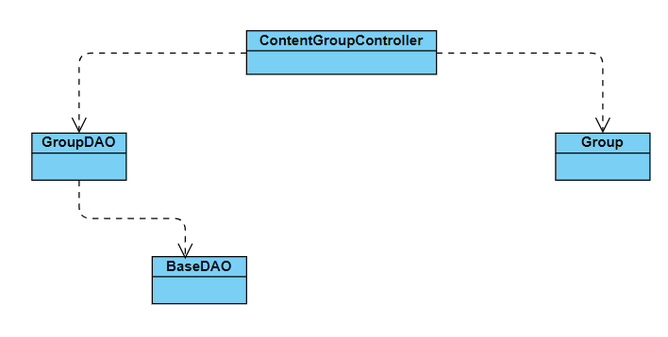

#### b. Sequence Diagram(s)

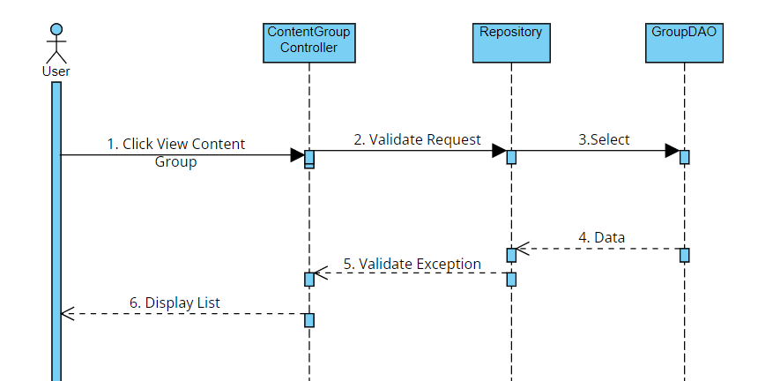

#### c. Database Queries

SELECT * FROM swp391_g3_flm.`group` where curriculum_id = ? and combo_subject = ? order by display_order limit ?, 10;

select count(*) from `group` where curriculum_id = ?

### 8.4 View Content Group Details

#### a.Class Diagram

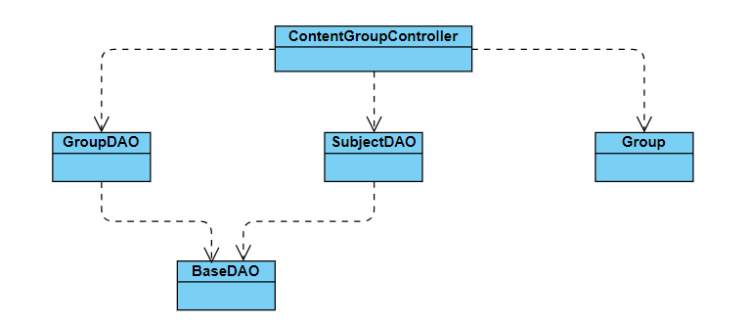

#### b. Sequence Diagram(s)

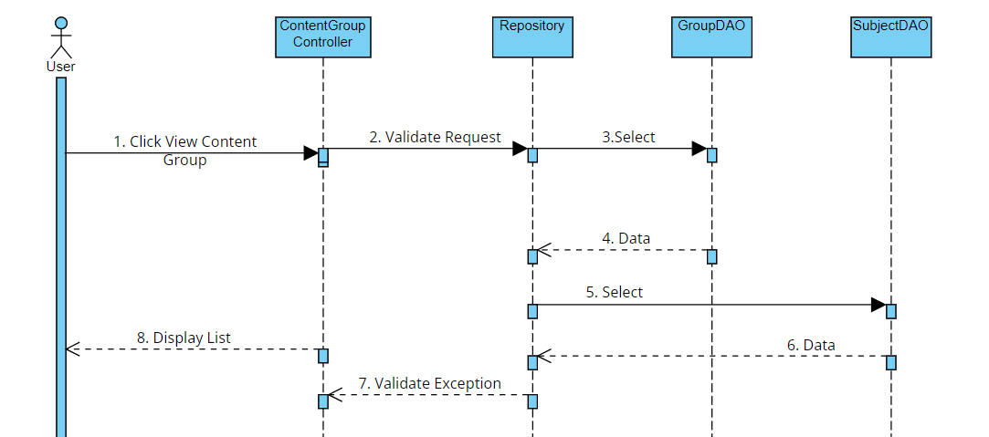

#### c. Database Queries

SELECT * FROM swp391_g3_flm.`group` where curriculum_id = ? and combo_subject = ? order by display_order limit ?, 10;

select count(*) from `group` where curriculum_id = ?

select * from `group` where group_id =?

select * from `group` where name =? and curriculum_id = ?

INSERT INTO `swp391_g3_flm`.`group` (`name`, `combo_subject`, `curriculum_id`, `display_order`, `is_active`) VALUES (?, ?, ?, ?, b?);

UPDATE `swp391_g3_flm`.`curriculum_subject` SET `group_id` = null WHERE (`group_id` = ?);

DELETE FROM `swp391_g3_flm`.`group` WHERE (`group_id` = ?);

### 8.5 View Elective List

#### a.Class Diagram

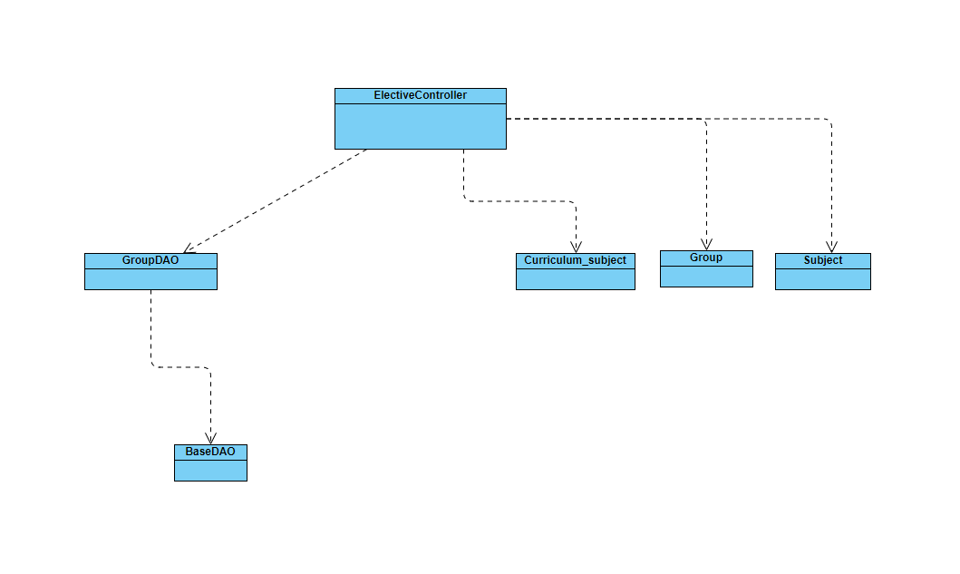

#### b. Sequence Diagram(s)

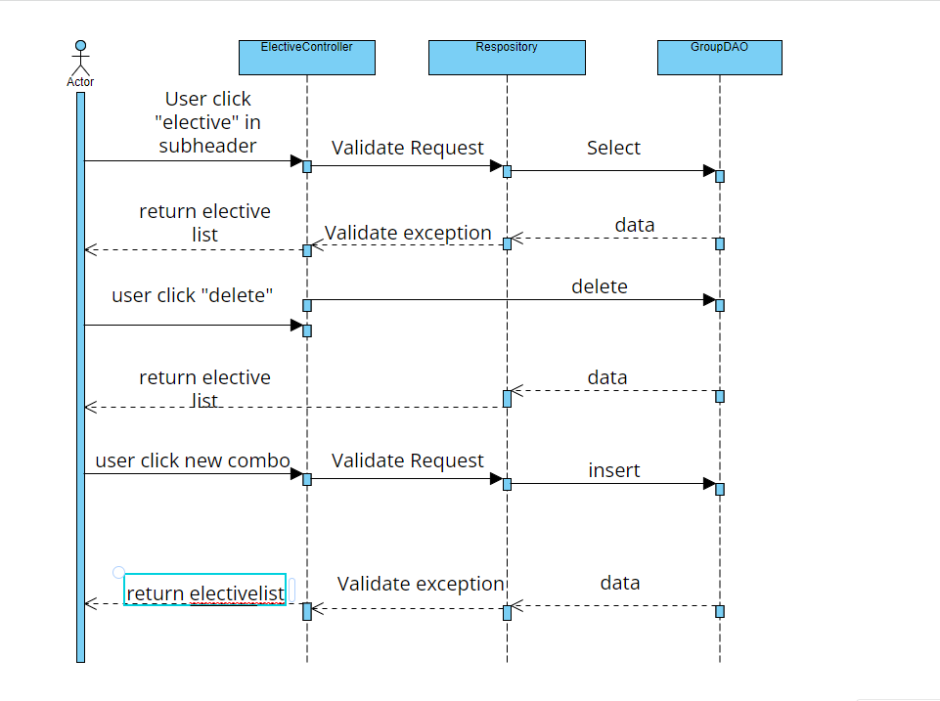

#### c. Database Queries

SELECT `group`.group_id,`group`.name,subject.code,subject.name "

+ "FROM swp391_g3_flm.curriculum_subject join subject "

+ "on curriculum_subject.subject_id = subject.subject_id "

+ "join `group` on `group`.group_id = subject.group_id "

+ "where curriculum_subject.curriculum_id = ? and type = 'Elective' and `group`.is_active = 1

### 8.6 View Elective Details

#### a.Class Diagram

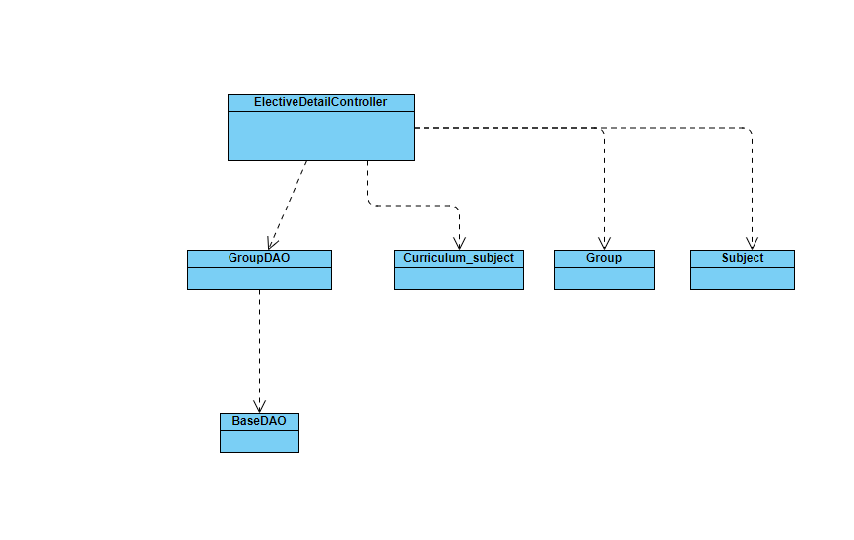

#### b. Sequence Diagram(s)

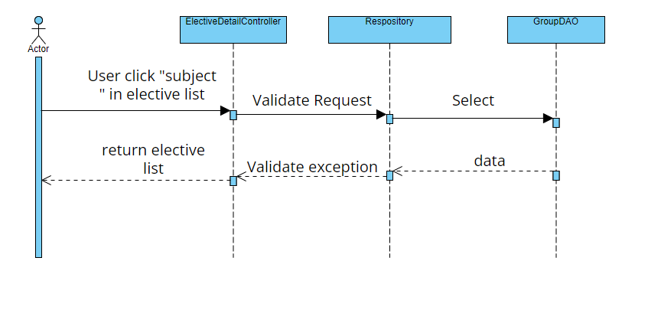

#### c. Database Queries

SELECT subject.subject_id,`group`.name,subject.code,subject.name "

+ "FROM swp391_g3_flm.curriculum_subject join subject "

+ "on curriculum_subject.subject_id = subject.subject_id "

+ "join `group` on `group`.group_id = subject.group_id "

+ "where curriculum_subject.curriculum_id = ? and type = 'Default' and `group`.group_id = ?

## Syllabus Management

### 9.1 View Syllabus List

#### a.Class Diagram

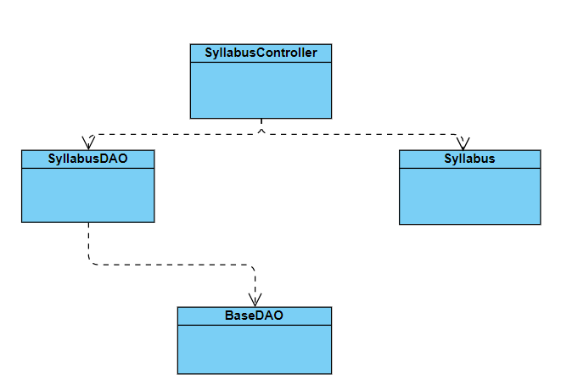

#### b. Sequence Diagram(s)

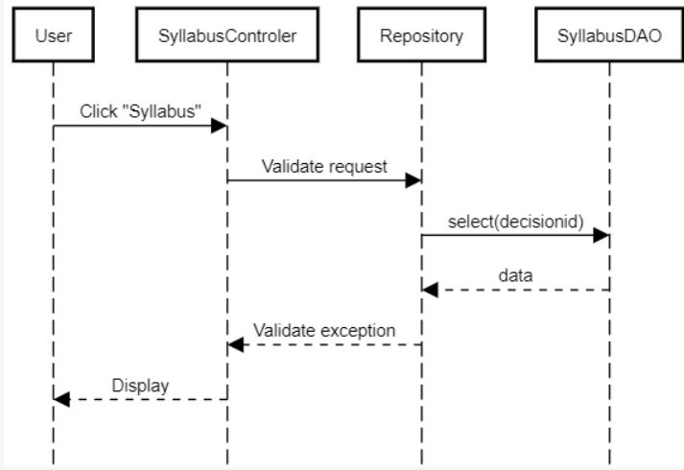

#### c. Database Queries

SELECT * FROM syllabus order by syllabus_id limit ?, 10

select count(*) from syllabus

SELECT * FROM syllabus where name like ? ;

### 9.2 View Syllabus Overview

#### a.Class Diagram



#### b. Sequence Diagram(s)

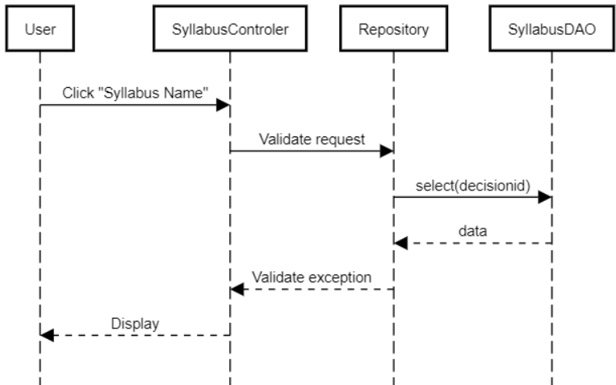

#### c. Database Queries

SELECT * FROM syllabus where syllabus_id = ?;

#### 9.3 Add Syllabus

#### a Class Diagram

#### 



#### b. Sequence Diagram(s)

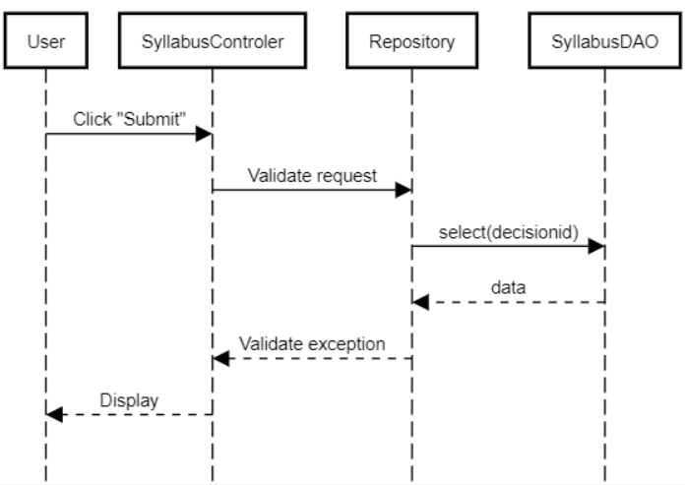

#### c. Database Queries

### 9.4 Edit Syllabus

#### a.Class Diagram



#### b. Sequence Diagram(s)

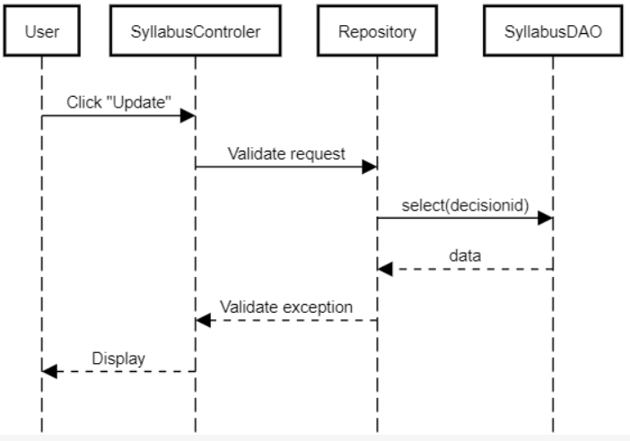

#### c. Database Queries

UPDATE syllabus SET name = ?, no_of_credit = ?, is_active = ?, is_approved = ?, degree_level = ?

WHERE syllabus_id = ?;

### 9.5 Import Syllabus

#### a.Class Diagram

#### b. Sequence Diagram(s)

#### c. Database Queries

## Decision Management

### 10.1 View Decision List

#### a.Class Diagram

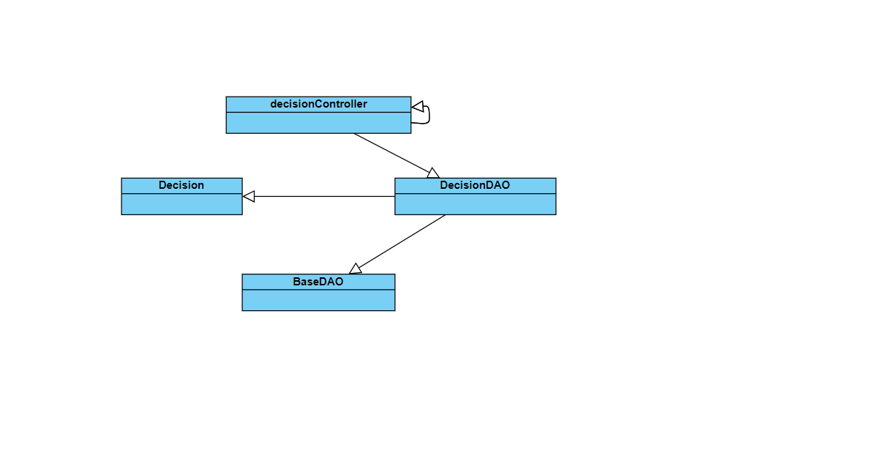

#### b. Sequence Diagram(s)

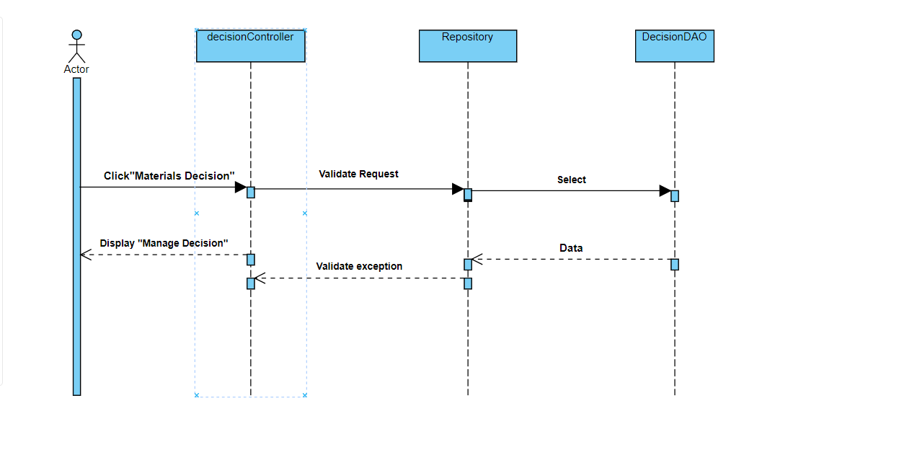

#### c. Database Queries

SELECT * FROM decision where creator_id = ? order by decision_id\n"

+ "limit ?, 10;"

select count(*) from decision

### 10.2 View Decision Details

#### a.Class Diagram

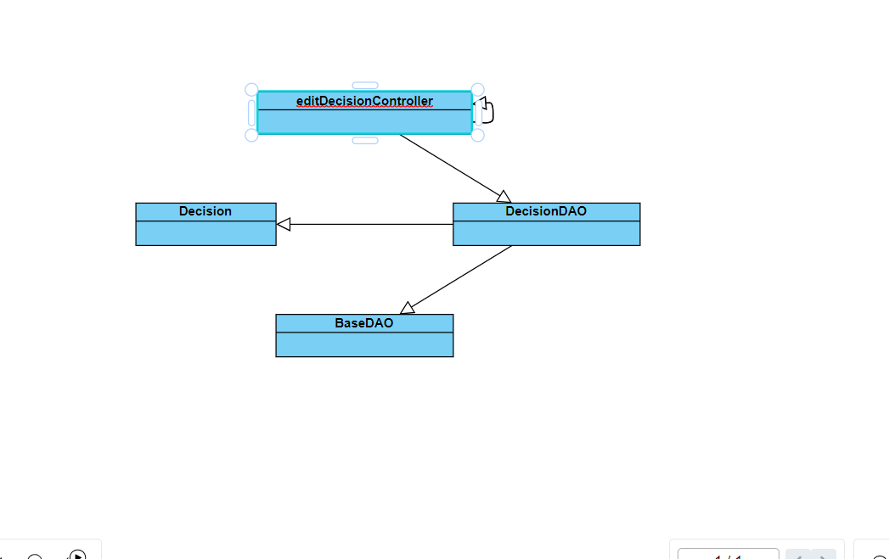

#### b. Sequence Diagram(s)

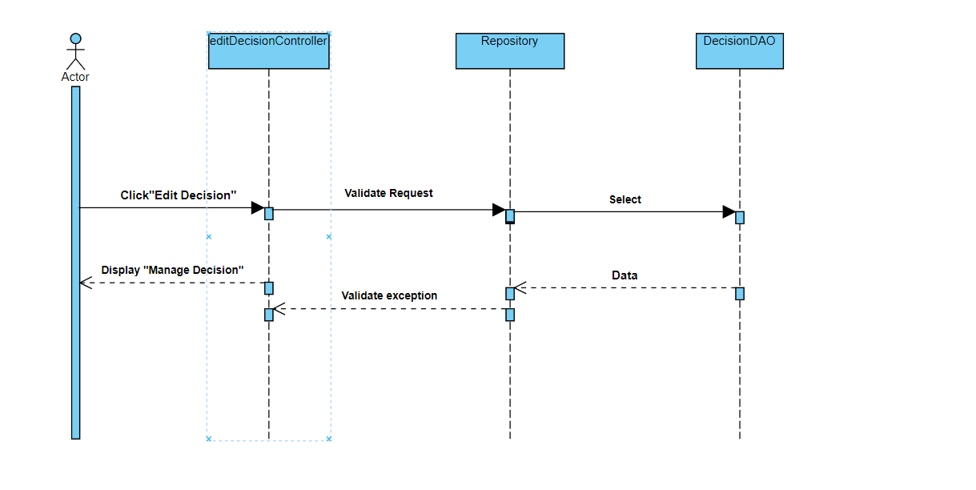

#### c. Database Queries

1.UPDATE `swp391_g3_flm`.`decision`"

+ " SET decision_no = ? ,decision_name = ? , decision_ApprovedDate = ? , note = ? , decision_CreateDate = ? , creator_id = ?"

+ "Where decision_id = ?

2.SELECT * FROM decision where creator_id = ? order by decision_id\n"

+ "limit ?, 10;

3.UPDATE `swp391_g3_flm`.`curriculum` SET decision_id = ? Where curriculum_id = ?

4.SELECT * FROM decision where decision_id = ?;

5.SELECT * FROM curriculum where decision_id is null;

### 10.3 Add New Decision

#### a.Class Diagram

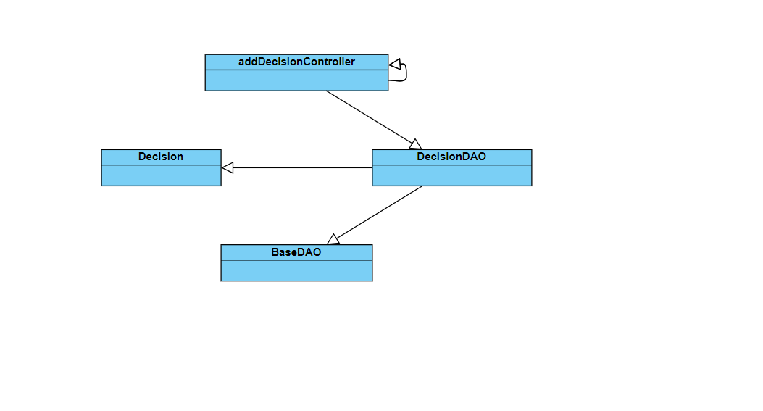

#### b. Sequence Diagram(s)

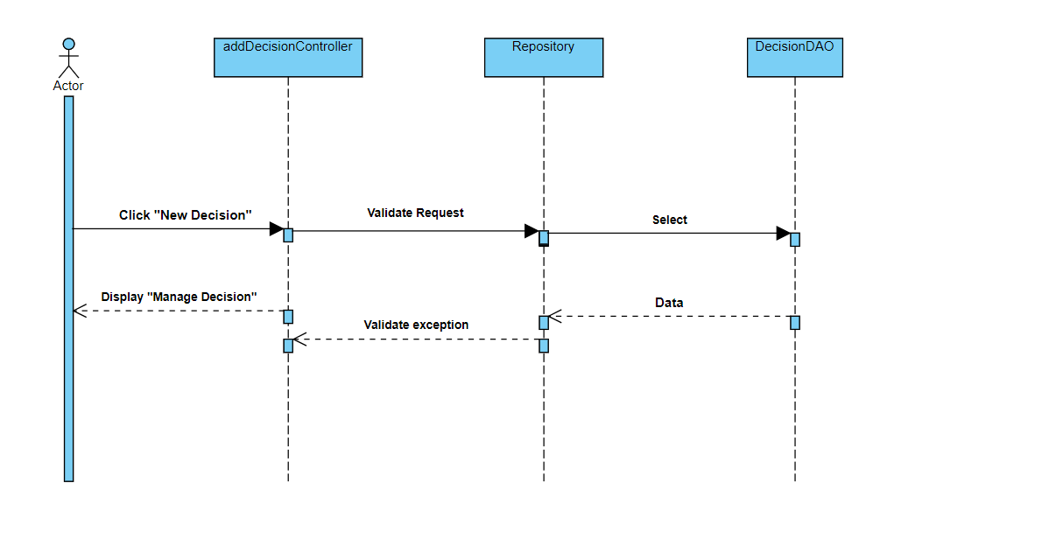

#### c. Database Queries

select * from decision where decision_no =?

INSERT INTO `swp391_g3_flm`.`decision` (`decision_no`, `decision_name`, `decision_date`, `creator_id`)"

+ " VALUES (?, ?, ?, ?);

SELECT * FROM decision where creator_id = ? order by decision_id\n"

+ "limit ?, 10;

### 10.4 View Decision Overview

#### a.Class Diagram



#### b. Sequence Diagram(s)

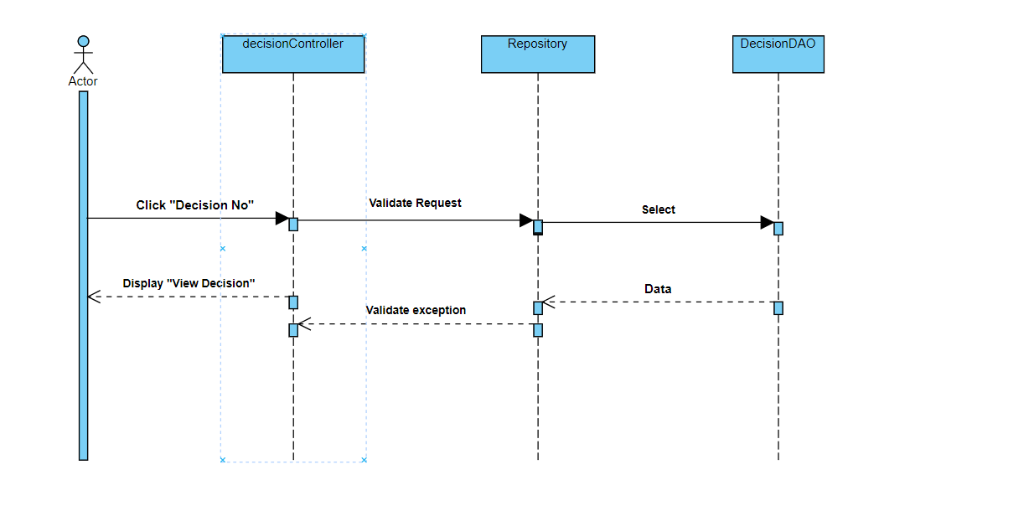

#### c. Database Queries

SELECT * FROM decision where decision_id = ?;

## Syllabus Submit

### 11.1 View Submit List

#### a.Class Diagram

#### b. Sequence Diagram(s)

#### c. Database Queries

### 11.2 View Submit Detail

#### a.Class Diagram

#### b. Sequence Diagram(s)

#### c. Database Queries

## Constructive Question

### 12.1 View Questions List

#### a.Class Diagram

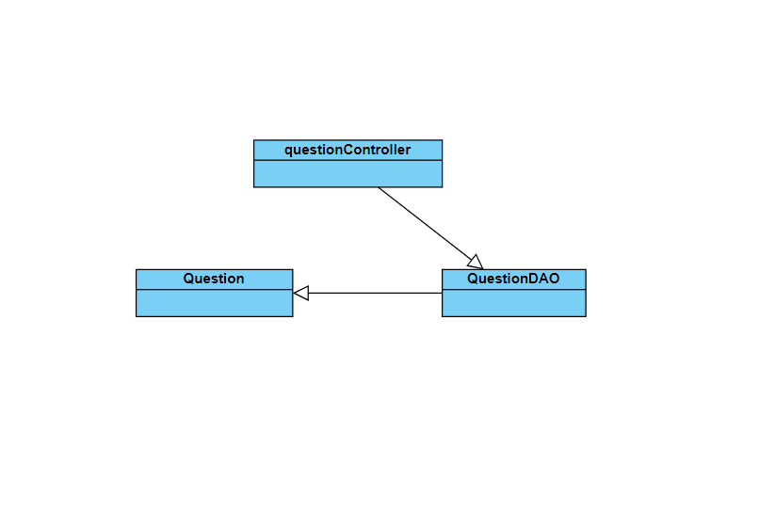

#### b. Sequence Diagram(s)

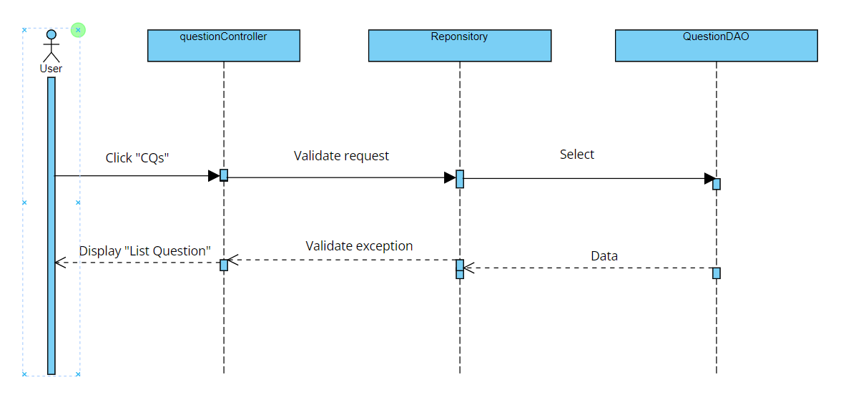

#### c. Database Queries

select * from question q join session s on q.session_id = s.session_id where s.syllabus_id = ? "

+ "limit ?, 10;

select count(*) from question q join session s on q.session_id = s.session_id where s.syllabus_id =?;

select * from question q join session s on q.session_id = s.session_id where (q.name like ? OR q.details like ?)and s.syllabus_id = ?;

### 12.2 View Questions Details

#### a.Class Diagram



#### b. Sequence Diagram(s)

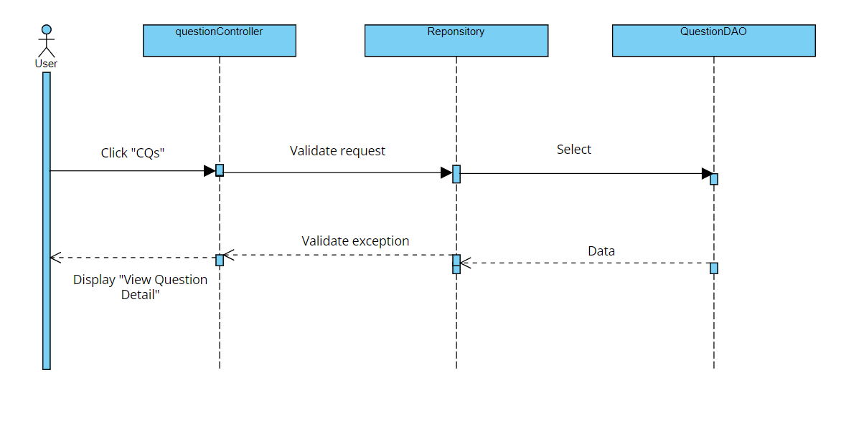

#### c. Database Queries

select * from question q join session s on q.session_id = s.session_id where s.syllabus_id = ? "

+ "limit ?, 10;

select count(*) from question q join session s on q.session_id = s.session_id where s.syllabus_id =?;

SELECT * FROM question where question_id = ?;

### 12.3 Import Questions

#### a.Class Diagram

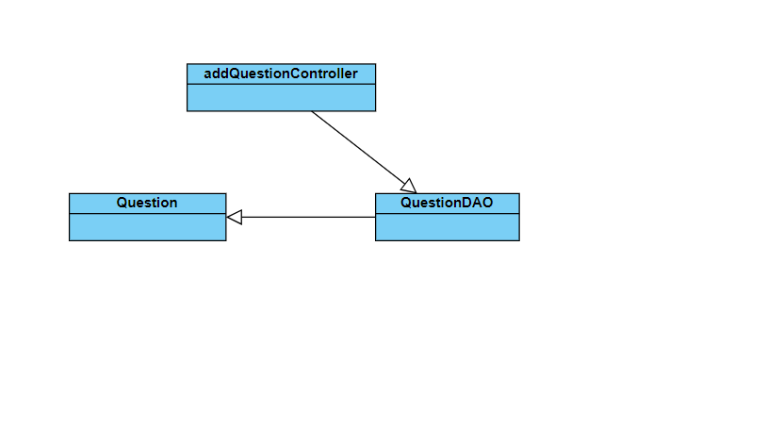

#### b. Sequence Diagram(s)

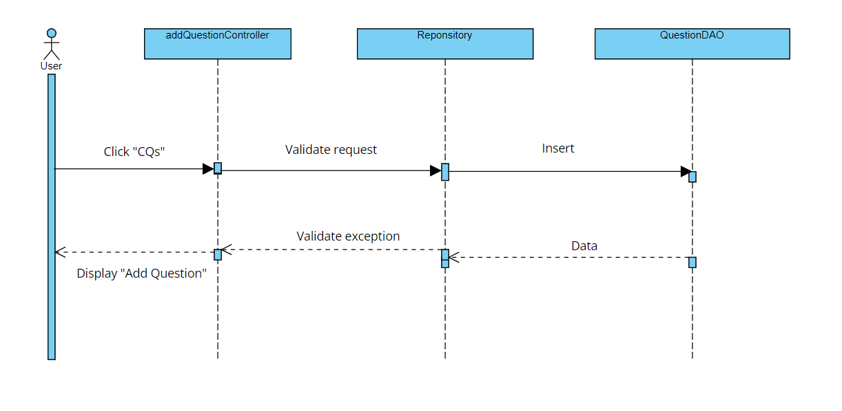

#### c. Database Queries

select count(*) from question q join session s on q.session_id = s.session_id where s.syllabus_id =?;

select * from question q join session s on q.session_id = s.session_id where s.syllabus_id = ? "

+ "limit ?, 10;

INSERT INTO `swp391_g3_flm`.`question` (`session_id`, `name`, `details`) VALUES (?, ?, ?);

## Session Management

### 13.1 View Session List

#### a.Class Diagram

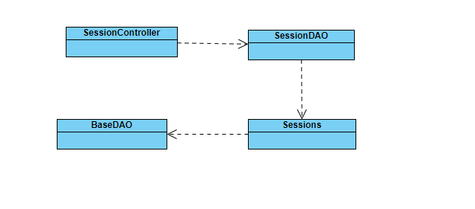

#### b. Sequence Diagram(s)

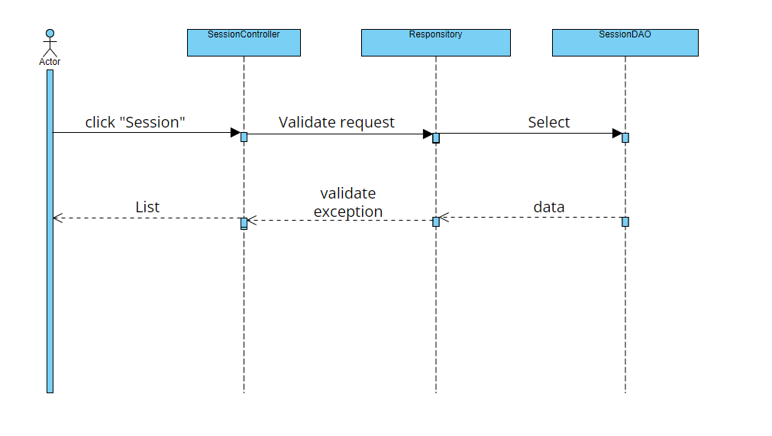

#### c. Database Queries

select session_id,syllabus_id,name,details,learning_type"

+ " from session where syllabus_id = ? "

+ "limit ?, 10;

### 13.2 View Session Details

#### a.Class Diagram

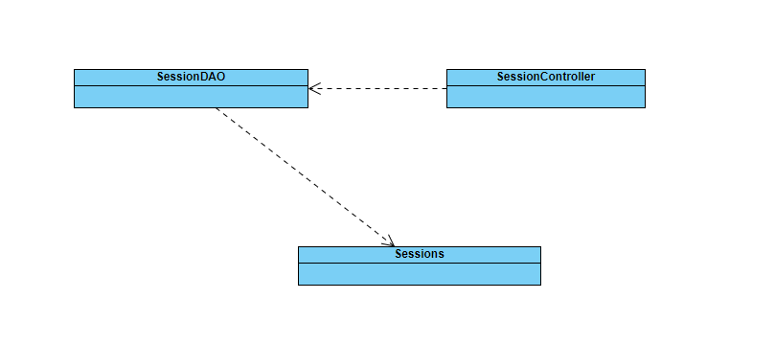

#### b. Sequence Diagram(s)

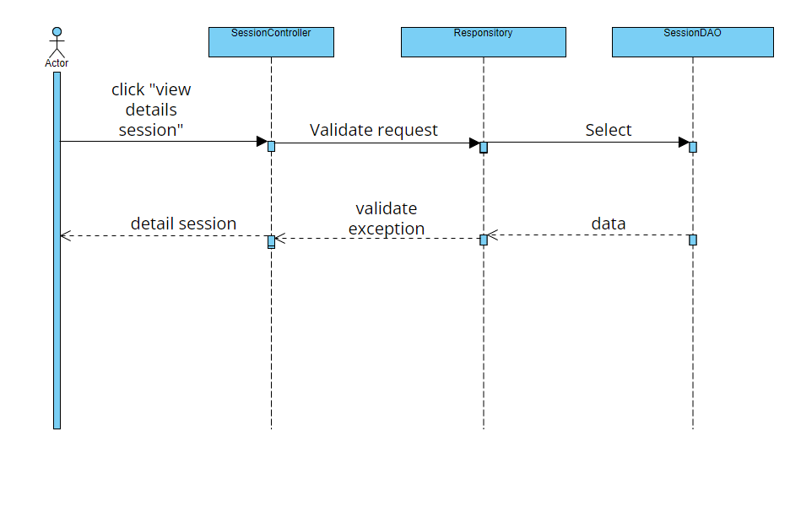

#### c. Database Queries

SELECT * FROM session where session_id = ?;

### 13.3 Import Session

#### a.Class Diagram

#### b. Sequence Diagram(s)

#### c. Database Queries

## CLO Management

### 14.1 View CLO List

#### a.Class Diagram

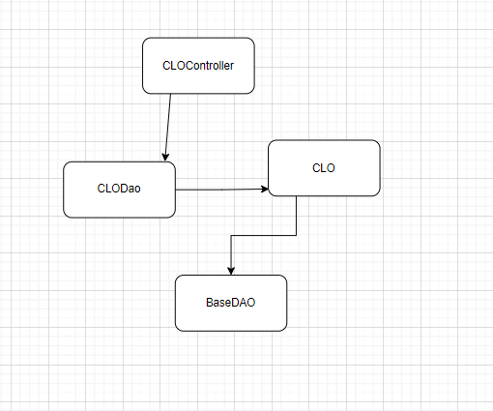

#### b. Sequence Diagram(s)

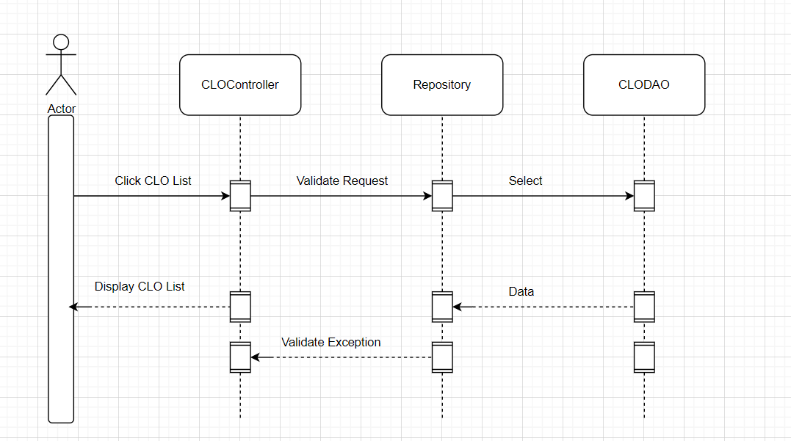

#### c. Database Queries

### 14.2 View CLO Details

#### a.Class Diagram



#### b. Sequence Diagram(s)

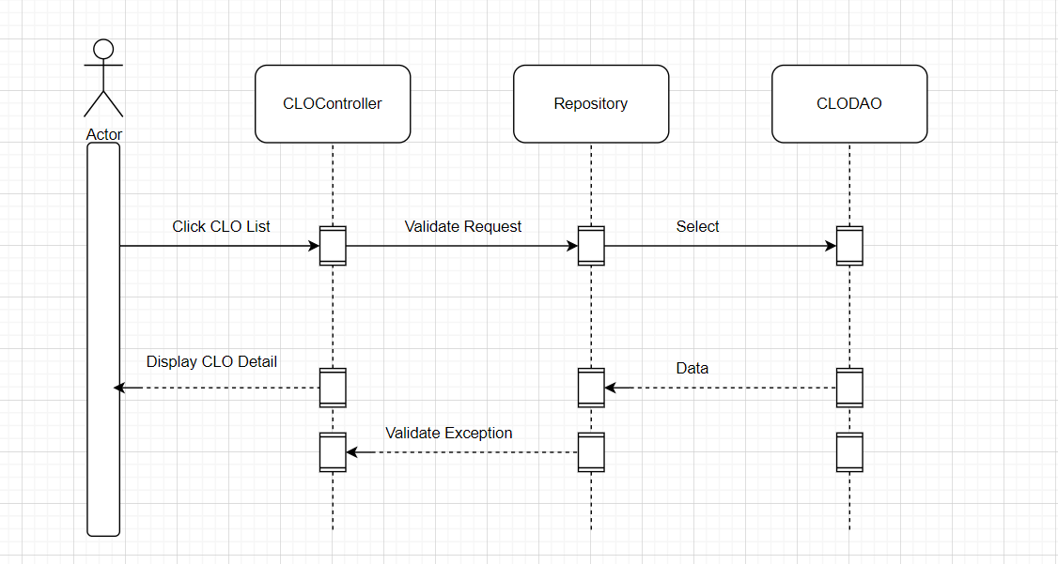

#### c. Database Queries

### 14.3 Import CLO

#### a.Class Diagram



#### b. Sequence Diagram(s)

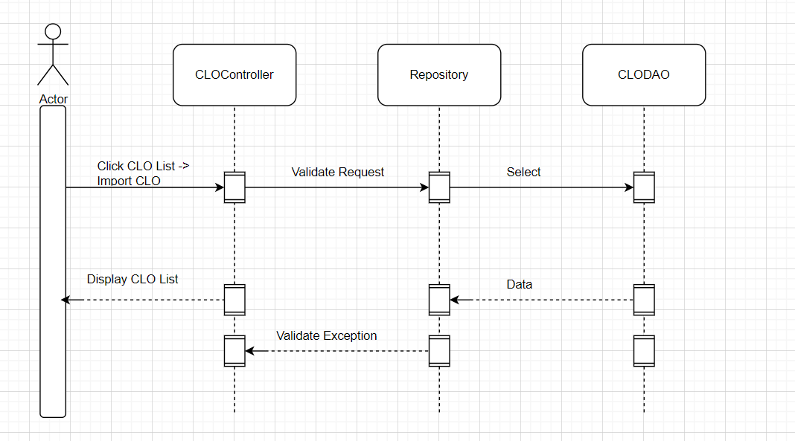

#### c. Database Queries

### 14.4 Mapping CLO-PLO

#### a.Class Diagram

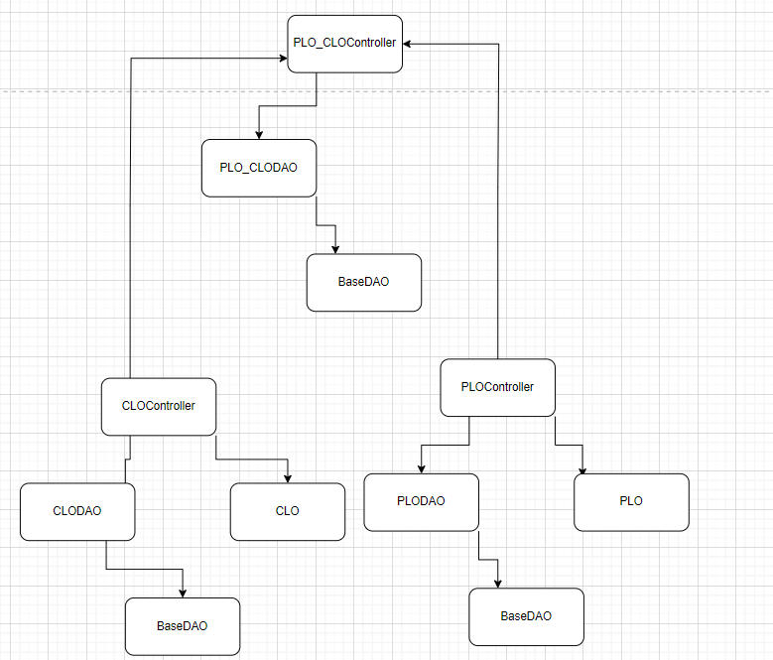

#### b. Sequence Diagram(s)

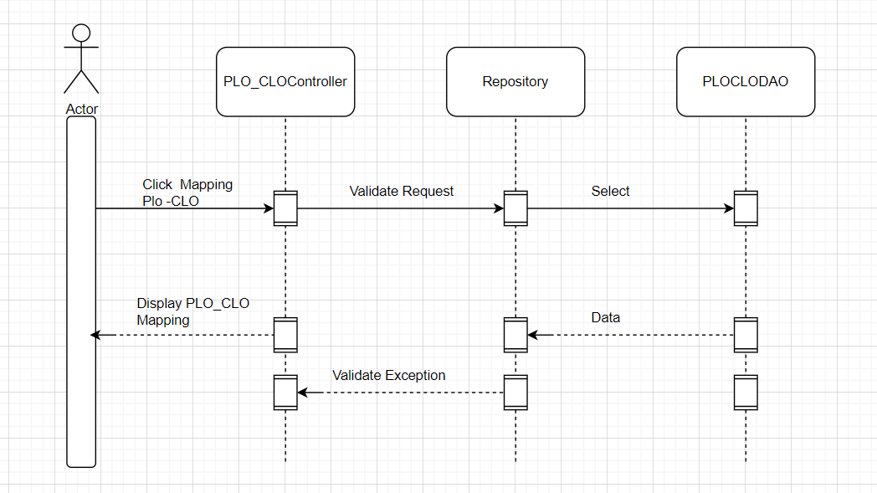

#### c. Database Queries

## Assessment Management

### 15.1 View Assessment List

#### a.Class Diagram

#### b. Sequence Diagram(s)

#### c. Database Queries

### 15.2 View Assessment Details

#### a.Class Diagram

#### b. Sequence Diagram(s)

#### c. Database Queries

## Reference Material

### 16.1 View Material List

#### a.Class Diagram

#### b. Sequence Diagram(s)

#### c. Database Queries

### 16.2 View Material Detail

#### a.Class Diagram

#### b. Sequence Diagram(s)

#### c. Database Queries